

**Mini Social Media**

**Software Requirement Specification**

**Project Code: Midia**

**Document Code: Midia – v1.0**

– Hanoi, June 2025 –

**Table of Contents**

Chapter 1. Record of Changes 3

Chapter 2. Software Requirement Specification 4

1. Product Overview 4

2. User Requirements 5

2.1 Actors 5

2.2 Use Cases 5

3. Software Features 9

3.1 Functional Overview 9

3.2 Notification 14

3.3 Content Management 22

3.4 User Settings 30

3.5 Follow System 33

3.6 Profile Management 36

3.7 Account Management 43

3.8 Home Features 51

3.9 Admin features 54

4. Non-Functional Requirements 58

4.1 External Interfaces 58

4.2 Quality Attributes 58

5. Requirement Appendix 58

5.1 Business Rules 58

5.2 Common Requirements 60

5.3 Application Messages List 60

# Chapter 1. Record of Changes

| **Date** | **A* M, D** | **In charge** | **Change Description** |
| --- | --- | --- | --- |
| 13/06/25 | A | ThangLT | First implementation. |
| 13/06/25 | A | SonDH | Add actor and actor description |
| 13/06/25 | D | SonDH | Delete unnecessary actor |
| 13/06/25 | A | SonDH | Add screen description Add screen flow Add screen authorization Add non-screen functions |
| 13/06/25 | A | ThangLT | Add context diagram and description. |
| 13/06/25 | A | SonDH | Add use case diagram |
| 13/06/25 | A | HoanTX | Add use case specification for User Setting |
| 14/06/25 | A | SonDH | Add entity relationship diagram and entity description  Add entity detail |
| 14/06/25 | A | ThangLT | Add mockup, screen item description for notification feature. Add Check Recent Noti, Atc on a Noti use case. |
| 14/06/25 | A, M | HoanTX | Add non-functional requirements Modify the use case’s specification |
| 15/06/25 | A | HoanTX | Add Edit profile, Post details and Follow suggestions use case specification |
| 15/06/25 | M | HoangMH | Modify ERD, entity detail |
| 15/06/25 | A | SonDH | Add use case View Posts, Create Post |
| 15/06/25 | A | KhanhNT | Add use case for home page screen. |
| 15/06/25 | M | ThangLT | Modify use case for post details Modify context diagram |
| 12/07/25 | M | HoanTX | Modify the use case “View Post Details” |
| 20/07/25 | A | ThangLT | Add admin-related use cases. |

*A - Added M - Modified D - Deleted

# Chapter 2. Software Requirement Specification

## 1. Product Overview

The Midia System is a lightweight social-media platform. Release 1.0 replaces the current set of static UI screens with full backend logic, APIs, and databases, allowing guests to browse public content and authenticated users to post, follow, and interact in real time. The context diagram (Figure 1-1) shows the boundary of the Midia application and its two external actors for the MVP. Future releases are expected to introduce third-party integrations such as push-notification services, content-moderation pipelines, etc.

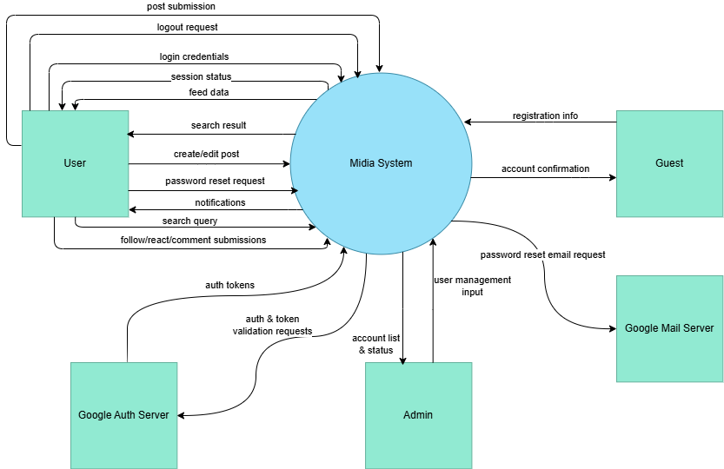

Figure 1.1: Midia System overview

As reflected in Figure 1-1 (Context Diagram), Midia exchanges information with two external entities. Each entity is outside the system boundary and communicates only through the labelled data flows.

* **Guest:** An unauthenticated visitor who consumes public-feed request, profile-view request, and search query flows. Midia replies with public-feed data, profile dataset, and search-result set. Guests cannot modify data or access private content.
* **Authenticated User:** A registered user with an active session token. Sends content payloads (new post, edit, like, comment), relationship records (follow/unfollow), real-time message packets, settings documents, and search queries. Receives personalised-feed data, post-confirmation set, interaction notifications, message packets, and search-result sets.

## 2. User Requirements

### 2.1 Actors

| **#** | **Actor** | **Description** |
| --- | --- | --- |
| 1 | Guest | A person who has not signed in or signed up. Can access login/register page, home or global search |
| 2 | User | An user who has signed up or signed in. Can create/edit posts, like, comment, follow others, manage profile, use messaging and interact with the system |
| 3 | Admin | An user which not only can use all of function of user, but also can manage user list and manage account status |

### 2.2 Use Cases

#### 2.2.1 Diagram(s)

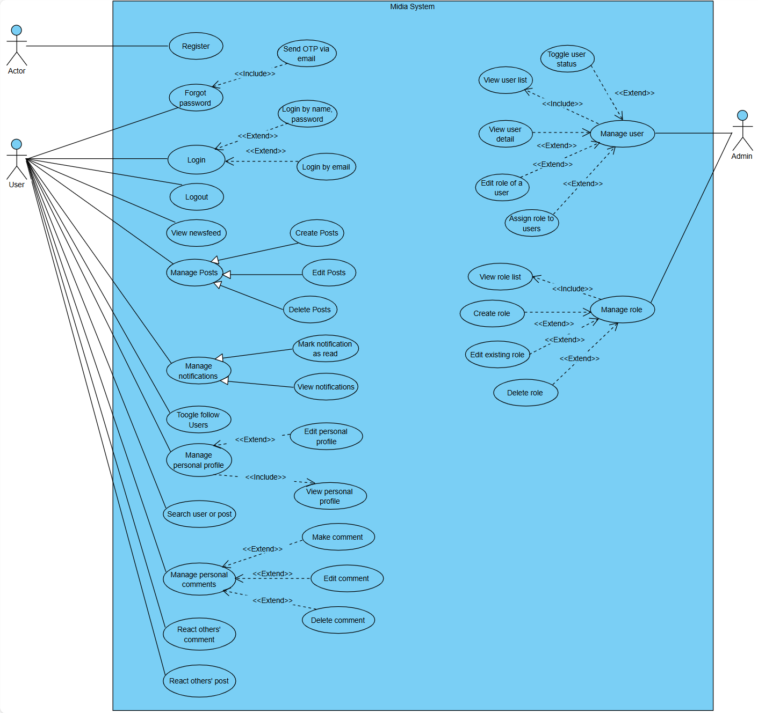

Figure 2-1: Use case diagram of Midia system

#### 2.2.2 Descriptions

| **ID** | **Group function** | **Use Case** | **Actors** | **Use Case Description & Main Flow** |
| --- | --- | --- | --- | --- |
| AM-01 | Account Management | Register | Guest | Allows a new guest to create an account.  Guest enters info → System validates → Creates account |
| AM-02 | Login | User | Allows a registered user to access the system.  User enters credentials → System authenticates → Grants access. |
| AM-03 |  | Forgot password | User | Allows a user to reset their password. User enters email → System sends reset link → User sets new password. |
| AM-04 |  | Logout | User | Allows a logged-in user to end their session. User clicks logout → System terminates session. |
| PM-01 | Profile Management | View Profile | User | Allows a user to view their own or another user's profile.  User navigates to profile → System displays info. |
| PM-02 | Edit Profile | User | Allows a user to update their profile information.  User navigates to edit profile page → Submits changes → System saves. |
| PM-03 | Follow Users | User | Allow user follow another user. User click Follow → System creates relationship → Updated. |
| PO-01 | Post Management | Create Post | User | Allows a user to share a new post with media and a caption.  User uploads media → Adds caption → Clicks share. |
| PO-02 | View Posts | User | Allows a user to view posts from followed users in their feed.  User opens feed → System displays posts. |
| PO-03 | Edit Post | User | Allows a user to modify their own post's caption.  User selects 'edit' on post → Makes changes → System updates. |
| PO-04 | Delete Post | User | Allows a user to delete their own post.  User selects 'delete' on post → Confirms → System removes post. |
| PO-05 | React Post | User | Allows a user to "like" or react to a post.  User clicks react button → System records the reaction. |
| CM-01 | Comment Management | Create Comment | User | Allows a user to add a comment to a post.  User types comment → Clicks post → System saves comment. |
| CM-02 | View Comment | User | Allows a user to view all comments on a specific post.  User opens post → System displays comments. |
| CM-03 | Edit Comment | User | Allows a user to modify their own comment.  User selects 'edit' → Makes changes → System updates comment. |
| CM-04 | Delete Comment | User | Allows a user to delete their own comment.  User selects 'delete' → Confirms → System removes comment. |
| CM-05 | React Comment | User | Allows a user to "like" or react to a comment.  User clicks react on a comment → System records reaction. |
| EF-01 | Extra Features | Search | User | Allows a user to search for other users or posts.  User enters query → System displays matching results. |
| EF-02 | View Notifications | User | Allows a user to see updates (likes, new comments, follows).  User opens notifications → System displays list. |
| AD-01 | Admin Functions | View User List | Admin | Allows an admin to see a list of all registered users.  Admin navigates to user list → System displays all users. |
| AD-02 | Toggle user status | Admin | Allows an admin to ban or activate a user account.  Admin selects user → Chooses action → System updates status. |
| AD-03 | View a user detail | Admin | Allows an admin to view a user detail, including username, social profiles, etc. |
| AD-04 | Edit user role | Admin | Allows an admin to modify role of an user |
| AD-05 | Assign role to users | Admin | Allows an admin to assign a role to one or many users at once. |
| AD-06 | View roles & permissions | Admin | Allows an admin to view present roles and permissions. |
| AD-07 | Customize roles | Admin | Allows an admin to add a role by changing its name or current permissions. |
| AD-08 | Modify existing roles | Admin | Allows an admin to modify existing roles. |
| NO-01 | Notifications | Check Recent Notifications | User | Allows a user to check recent notifications in time grouped. |
| NO-02 | Mark notifications as read | User | Allows a user to mark one or many notifications as read state.  User clicks on notification bell -> Chooses mark as read |
| NO-03 | Receive notifications in real time | User | Allows a user to receive notifications in real time. |

## 3. Software Features

### 3.1 Functional Overview

#### 3.1.1 Screens Flow

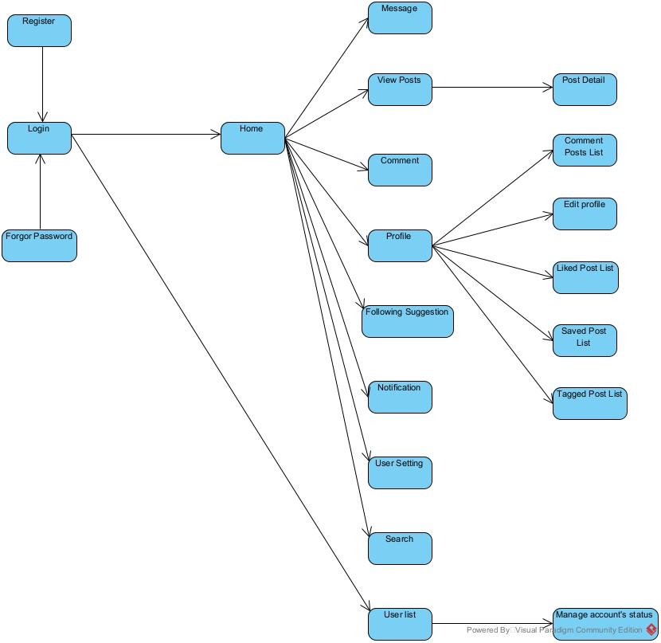

#### 3.1.2 Screen Descriptions

| **#** | **Feature** | **Screen** | **Description** |
| --- | --- | --- | --- |
| 1 | Authentication & Session | Login | Allows users to log into their account using email/username and password. |
| 2 | Authentication & Session | Register | Enables new user to create an account by providing email, username, password |
| 3 | Navigation | Global Layout | Provides consistent header and navigation bar visible across authenticated screens includes link to Home, Search and Message |
| 4 | Home Feed | Newsfeed Page | Display a list of posts from followed users, sorted by recency. Support infinite scroll |
| 5 | Content Management | Create Post | Modal dialog allowing users to create a new post, including for content, media uploads and tags |
| 6 | Content Management | PostDetails View | Detailed view of a single post including full content, comments, like count and user interaction |
| 7 | Content Management | Archive View | Display a list of archived posts for the logged-in user in grid or list format |
| 8 | Social Interaction | Comments | Interface showing comments on a post. Allows adding, editing and deleting own comments. |
| 9 | Social Interaction | Likes Post List | Shows a list of users who liked a particular post, along with follow/unfollow actions |
| 10 | User Profiles | Profile Page | Display user’s posts, saved content and tagged posts in tabbed views- |
| 11 | User Profiles | Edit Profile | Allows users to update their profile information including avatar, bio and personal links |
| 12 | Notifications | Notifications Center | List recent notifications (likes, comments, follows) with link to related content |
| 13 | Follow System | Follow Suggestions | Display recommended users to follow with “Follow” button for each |
| 14 | Global Search | Search | Allows users to search posts, users and tags. Display results in categorized sections |
| 15 | User settings | User settings | Provides UI to manage account settings, privacy options and notification preferences |
| 16 | Real-Time Messaging | Message | Real-time chat interface showing list of conversations and individual chat threads with live updates |
| 17 | User Management | User list | Display a table list of users. When click detail, show all the information of that user |
| 18 | User Management | Manage account |  |

#### 3.1.3 Screen Authorization

| **#** | **Screen** | **Guest** | **User** |
| --- | --- | --- | --- |
| 1 | Login | X |  |
| 2 | Register | X |  |
| 3 | Newsfeed Page |  | X |
| 4 | Create post |  | X |
| 5 | Comment |  | X |
| 6 | Post Details View |  | X |
| 7 | Likes Post List |  | X |
| 8 | Profile Page |  | X |
| 9 | Edit Profile |  | X |
| 10 | Notification Center |  | X |
| 11 | Follow Suggestions |  | X |
| 12 | Search |  | X |
| 13 | User settings |  | X |
| 14 | Message |  | X |

#### 3.1.4 Non-Screen Functions

| **#** | **Feature** | **System Function** | **Description** |
| --- | --- | --- | --- |
| 1 | Authentication & Session | Auth API | Provides login, registration, and logout endpoints to manage authentication via RESTful APIs. |
| 2 | Authentication & Session | JWT / Session Management | Issues, validates, and refreshes JWT tokens to maintain secure session state across the system. |
| 3 | Real-Time Messaging | WebSocket Server | Manages real-time bidirectional communication between users for chat and typing indicators |

#### 3.1.5 Entity Relationship Diagram

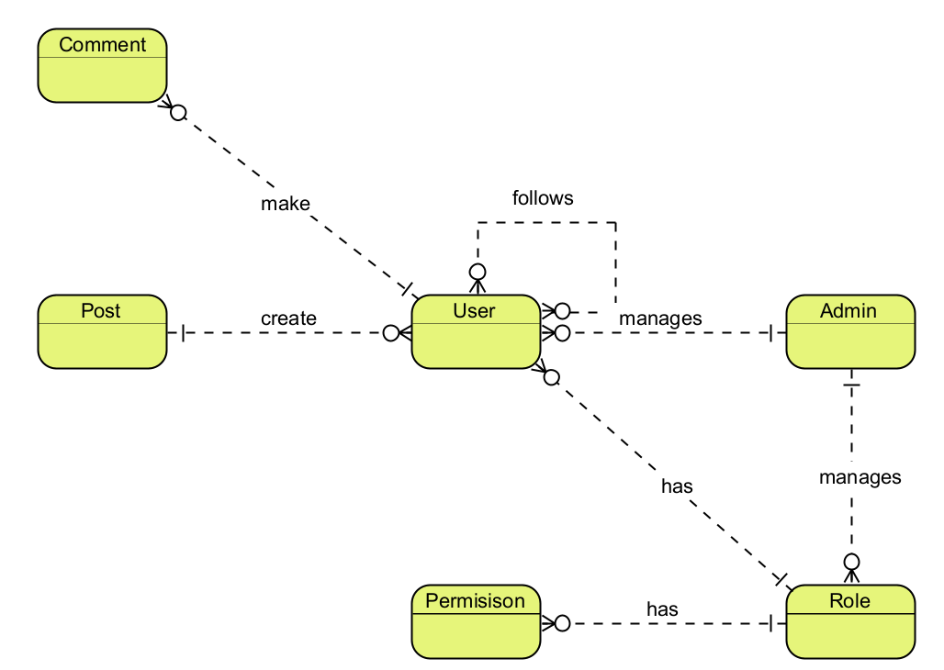

**Entities Description**

| **#** | **Entity** | **Description** |
| --- | --- | --- |
| 1 | User | Represents user’s information such as id, username, email, encrypted password, followers, followings, status and audit information. |
| 2 | Post | Stores user-generated posts, including caption, attachments, visibility and interaction statistics |
| 3 | Comment | Stores user comments on posts, which may include attachments and reaction statistics |
| 4 | Role | Represents user’s role in the system |
| 5 | Permission | Represents actions user can perform in the system. |
| 6 | Admin | Represent administrators, who manages users and roles in midia system. |

#### 3.1.6 Entity Details

##### 3.1.6.1 User

| **#** | **Attribute name** | **PK** | **Type** | **Mandatory** | **Description** |
| --- | --- | --- | --- | --- | --- |
| 1 | ID | x | uuid | Yes | Primary key that uniquely identifies each user. |
| 2 | User name |  | string | Yes | Display name of the user |
| 3 | Email |  | string | Yes | User’s email address |
| 4 | Password |  | string (hashed) | Yes | Encrypted password |
| 5 | Created at |  | timestamp | Yes | Timestamp when the user was created. |
| 6 | Updated at |  | timestamp | No | Timestamp when the user was updated. |
| 7 | Deleted at |  | timestamp | No | Soft-delete timestamp. If set, the account is considered deleted. |
| 8 | Is locked |  | boolean | Yes (default: false) | Indicates whether the user's account is locked |
| 9 | Profile |  | Reference | Yes | Reference to user’s profile |
| 10 | Stats |  | Reference | Yes | Reference to user’s stats |
| 11 | Followers |  | Set<Reference> | No | A set of references to other users who follow this user. |
| 12 | Followings |  | Set<Reference> | No | A set of references to other users this user follows |
| 13 | Uid |  | string | Yes | Automatic unique generated internal id |

##### 3.1.6.2 UserProfile

| **#** | **Attribute name** | **PK** | **Type** | **Mandatory** | **Description** |
| --- | --- | --- | --- | --- | --- |
| 1 | Uid | x | string | Yes | Automatic unique generated profile id |
| 2 | Avatar |  | string | Yes | URL or reference to avatar image |
| 3 | Bio |  | string | No | User’s biography |
| 4 | User id |  | Reference | Yes | Associated user |

##### 3.1.6.3 UserStats

| **#** | **Attribute name** | **PK** | **Type** | **Mandatory** | **Description** |
| --- | --- | --- | --- | --- | --- |
| 1 | User id | x | string | Yes | Automatic unique generated profile id |
| 2 | Number of posts |  | int | Yes | Number of posts made by the user |
| 3 | Number of following |  | int | Yes | Number of users the user is following |
| 4 | Number of followers |  | int | Yes | Number of followers |
| 5 | User id |  | Reference | Yes | Associated user |

##### 3.1.6.4 Post

| **#** | **Attribute name** | **PK** | **Type** | **Mandatory** | **Description** |
| --- | --- | --- | --- | --- | --- |
| 1 | id | x | uuid | Yes | Primary key that uniquely identifies the posts. |
| 2 | caption |  | string | Yes | The content of the posts |
| 3 | Created at |  | timestamp | Yes | Time when the post was created |
| 4 | Visibility |  | enum | Yes | Visibility setting of the post (‘PUBLIC’,‘PRIVATE’, ‘FRIENDS’) |
| 5 | Deleted at |  | timestamp | No | Time when post is deleted. |
| 6 | Updated at |  | timestamp | No | Timestamp when the post was updated. |
| 7 | Author id |  | Reference | Yes | Reference to user who create the post |
| 8 | Like count |  | string | No | The number of like in the post |

##### 3.1.6.5 Comment

| **#** | **Attribute name** | **PK** | **Type** | **Mandatory** | **Description** |
| --- | --- | --- | --- | --- | --- |
| 1 | Id | x | uuid | Yes | Primary key that uniquely identifies the comments. |
| 2 | Content |  | string | Yes | The text content of the comment |
| 3 | Created at |  | timestamp | Yes | Time when comment was created |
| 4 | Update at |  | timestamp | No | Timestamp when the comment was updated. |
| 5 | Deleted at |  | timestamp | Yes | Timestamp when the comment was created. |
| 6 | Post id |  | Reference | Yes | Associated post |
| 7 | User id |  | Reference | Yes | User who wrote the comment |

##### 3.1.6.6 Attachment

| **#** | **Attribute name** | **PK** | **Type** | **Mandatory** | **Description** |
| --- | --- | --- | --- | --- | --- |
| 1 | Id | x | uuid | Yes | Primary key that uniquely identifies the attachment. |
| 2 | Title |  | String | No | The title of the attachment |
| 3 | Description |  | string | Yes | The detail text for the attachment |
| 4 | Original link |  | string | Yes | Link to the original file (full size, original quality) |
| 5 | Created at |  | datetime | Yes | Time when the attachment was created. |
| 6 | Metadata |  | json | No | Additional information (e.g. size, resolution, duration, format). |
| 7 | Optimized link |  | string | No | Link to the optimized, compressed version. |
| 8 | Delete at |  | timestamp | No | Time when the attachment is deleted |

##### 3.1.6.7 Role

| **#** | **Attribute name** | **PK** | **Type** | **Mandatory** | **Description** |
| --- | --- | --- | --- | --- | --- |
| 1 | uid | X | string | Yes | Unique ID of the role |
| 2 | name |  | enum | Yes | Role name (default: ‘GUEST’, ‘USER’, ‘ADMIN’) |

##### 3.1.6.8 Permission

| **#** | **Attribute name** | **PK** | **Type** | **Mandatory** | **Description** |
| --- | --- | --- | --- | --- | --- |
| 1 | uid | X | string | Yes | Unique ID of the permission |
| 2 | name |  | string | Yes | Name of permission |
| 3 | Role id |  | Reference | Yes | Which role this permission belongs to. |

### 

### 3.2 Notification

#### 3.2.1 Check Recent Notifications

##### 3.2.1.1 Screen Mock-up

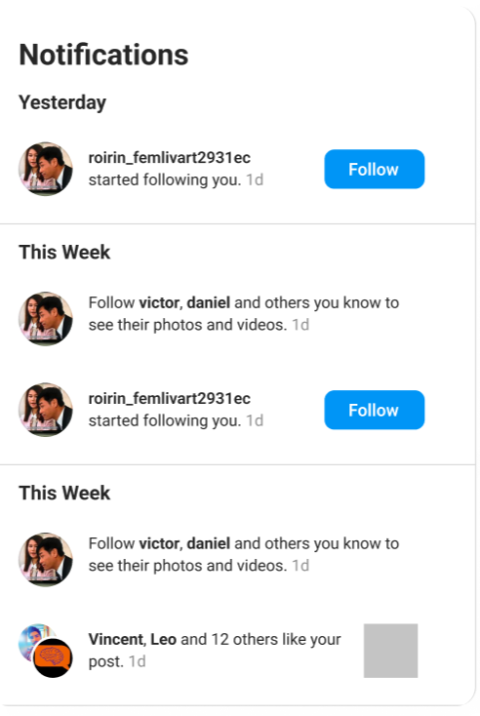

**Figure 3-1**: Notification modal

**Table 3-1: Screen Definition**

| **#** | **Field Name** | **Type** | **Mandatory** | **Max Length** | **Description** |
| --- | --- | --- | --- | --- | --- |
| 1 | Call-to-action button label | String | No | N/A | Caption on the call-to-action button when the notification requires a response (e.g., **“Follow”**, **“Following”**). Hidden for non-interactive notifications. |
| 2 | Destination link | URL | Yes | 2083 | With this field in place, every notification item can seamlessly deep-link to the related post or user profile. |
| 3 | Relative time label | String | Yes | 10 | Relative time stamp (“1 d”, “3 h”). Concise ≤ 5 chars plus a trailing space if displayed inline. |
| 4 | Activity description | String | Yes | 200 | Full descriptive sentence that follows the actors (e.g., *“started following you.”*, *“… like your post.”*). Includes punctuation. |
| 5 | List of actor names | String | Yes | 100 | Human-readable list of actors shown in bold (e.g., *“roirin_femlivart2931ec”* or *“Vincent, Leo and 12 others”*). |
| 6 | Section title | String | Yes | 20 | Group label that partitions the list chronologically (e.g., “Yesterday”, “This Week”). |

##### 3.2.1.2 Use Case Description

| **Use Case ID** | | **EF-02** | **Use Case Name** | | **Check Recent Notifications** | |
| --- | --- | --- | --- | --- | --- | --- |
| **Author** | | **ThangLT** | **Version** | **1.0** | **Date** | **14/06/2025** |
| **Actor** | | Authenticated User | | | | |
| **Description** | | Allows a logged-in user to view their most recent notifications. The system automatically marks notifications as "read" once they are displayed to the user. | | | | |
| **Precondition** | | PRE-01: The user is logged into the system.  PRE-02: The user has one or more notifications waiting to be viewed. | | | | |
| **Trigger** | | TRG-01: User clicks the notification bell icon. | | | | |
| **Post-Condition** | | POS-01: The user's most recent notifications are displayed.  POS-02: The displayed notifications are marked as read.  POS-03: The unread notification counter is updated. | | | | |
| **Main flows** | | | | | | |
| ***Step*** | ***Actor*** | ***Action*** | | | | |
| *1* | Auth User | Clicks the bell icon. | | | | |
| *2* | System | Displays a list of the user's most recent notifications, grouped into sections like "Today," "Yesterday," and "This Week." | | | | |
| *3* | System | Authorises request, queries for the latest 20 notifications, sorted by createdAt DESC. | | | | |
| *4* | System | Automatically marks the viewed notifications as read and updates the unread notification count. | | | | |

**Alternative flows**

| **AT1** | At step 2 of the Normal Flow, if the system is unable to retrieve the notifications for any reason. | |
| --- | --- | --- |
| **Sub step** | **Actor** | **Action** |
| 2.1 | Midia | The system displays a message, such as: "Unable to load notifications. Please try again later." |

| **AT2** | At step 2 of the Normal Flow, if the user has no notifications. | |
| --- | --- | --- |
| **Sub step** | **Actor** | **Action** |
| 3.1 | Midia | The system displays an informative message, such as: "You're all caught up!" and shows the unread notification count as zero. |

***Business Rules***

| **#** | **Rule Description** |
| --- | --- |
| BR-01 | The system displays a maximum of 20 notifications per page. |
| BR-02 | A notification is considered "unread" until it has been displayed to the user. |
| BR-03 | Notifications are always displayed in order from newest to oldest. |
| BR-04 | Notifications older than 30 days are automatically archived and will not appear in the recent notifications list. |
| BR-05 | If the number of unread notifications is greater than 99, the counter will display "99+". |

#### 3.2.2 Mark Notifications as Read

##### 3.2.2.1 Use Case Description

| **Use Case ID** | | **NO-02** | **Use Case Name** | | **Mark Notifications as Read** | |
| --- | --- | --- | --- | --- | --- | --- |
| **Author** | | **ThangLT** | **Version** | **1.0** | **Date** | **20/07/2025** |
| **Actor** | | Authenticated User | | | | |
| **Description** | | This use case allows an authenticated user to mark one or all unread notifications as read. The system updates the status accordingly and refreshes the count of unread notifications displayed to the user. | | | | |
| **Precondition** | | PRE-01: User is signed in.  PRE-02: The user has at least one unread notification. | | | | |
| **Trigger** | | TRG-01: The user clicks on a specific unread notification.  TRG-02: Or the user clicks a button or link to mark all notifications as read. | | | | |
| **Post-Condition** | | POS-01: The selected notification(s) are marked as read.  POS-02: The count of unread notifications is updated. | | | | |
| **Flow A - mark a single notification as read** | | | | | | |
| ***Step*** | ***Actor*** | ***Action*** | | | | |
| *1* | Auth User | Interacts with a single unread notification. | | | | |
| *2* | System | Marks the notification as read. | | | | |
| *3* | System | Updates the unread notification count. | | | | |
| *4* | System | Visually changes the notification to indicate it has been read. | | | | |
| **Flow B - mark all notifications as read** | | | | | | |
| ***Step*** | ***Actor*** | ***Action*** | | | | |
| *1* | Auth User | Clicks a button or link labeled “Mark all as read.” | | | | |
| *2* | System | Marks all unread notifications for the user as read. | | | | |
| *3* | System | Sets the unread notification count to zero. | | | | |
| *4* | System | Visually changes all unread notifications to indicate they have been read. | | | | |

**Alternative flows**

| **AT1** | User is Not Authenticated | |
| --- | --- | --- |
| **Sub step** | **Actor** | **Action** |
| 1.1 | System | Detects the user is not signed in. |
| 1.2 | System | Shows an error message or redirects the user to sign in. |

| **AT2** | Invalid or Missing notification | |
| --- | --- | --- |
| **Sub step** | **Actor** | **Action** |
| 2.1 | Midia | The System cannot identify the selected notification (e.g., it does not exist). |
| 2.2 | Client | The System shows an error message: “Failed to update notification.” |

***Business Rules***

| **#** | **Rule Description** |
| --- | --- |
| BR-36 | Marking a notification as read more than once has no effect beyond the first time (the operation is idempotent). |
| BR-37 | Only authenticated users can mark their notifications as read. |
| BR-38 | A notification is considered “read” once its status has been updated accordingly. |
| BR-39 | The “Mark all as read” action only applies to the current user’s notifications. |

#### 3.2.3 Receiving notifications in real time

##### 3.2.3.1 Use Case Description

| **Use Case ID** | | **NO-03** | **Use Case Name** | | **Receiving notifications in real time** | |
| --- | --- | --- | --- | --- | --- | --- |
| **Author** | | **ThangLT** | **Version** | **1.0** | **Date** | **20/07/2025** |
| **Actor** | | Authenticated User | | | | |
| **Description** | | The system instantly displays new notifications to a logged-in user as they occur, ensuring they are always aware of recent activity. | | | | |
| **Precondition** | | PRE-01: The user is logged into the system. | | | | |
| **Trigger** | | TRG-01: Another user performs an action that generates a notification for the logged-in user (e.g., liking their post, following them). | | | | |
| **Post-Condition** | | POS-01: The new notification immediately appears on the user's screen.  POS-02: The unread notification counter is updated. | | | | |
| **Flow A - mark a single notification as read** | | | | | | |
| ***Step*** | ***Actor*** | ***Action*** | | | | |
| *1* | System | A new notification is generated for the logged-in user. | | | | |
| *2* | System | Instantly presents the new notification on the user's screen (e.g., as a pop-up or by adding it to the notification list). | | | | |
| *3* | System | Updates the unread notification count. | | | | |

**Alternative flows**

| **AT1** | If the user's connection to the notification service is lost. | |
| --- | --- | --- |
| **Sub step** | **Actor** | **Action** |
| 3.1 | Midia | The system will attempt to show any missed notifications the next time the connection is restored or when the user manually checks their notifications. |

| **AT2** | If the user is not properly logged in when trying to listen for notifications. | |
| --- | --- | --- |
| **Sub step** | **Actor** | **Action** |
| 1 | Midia | The system will not establish a connection for real-time updates. |

***Business Rules***

| **#** | **Rule Description** |
| --- | --- |
| BR-40 | Real-time updates are delivered over GraphQL Subscriptions, which operate on a WebSocket connection. |
| BR-41 | The system maintains a map of active subscribers on the backend to direct real-time notifications only to the intended recipients. |
| BR-42 | A polling mechanism is implemented as a fallback. It runs every 10 seconds to query for recent notifications, ensuring eventual delivery if the real-time push fails. |
| BR-43 | Each subscription is tied to a specific authenticated user. A user can only subscribe to and receive their own notifications. |

### 3.3 Content Management

#### 3.3.1 Create Post

##### 3.3.1.1 Screen Mock-up

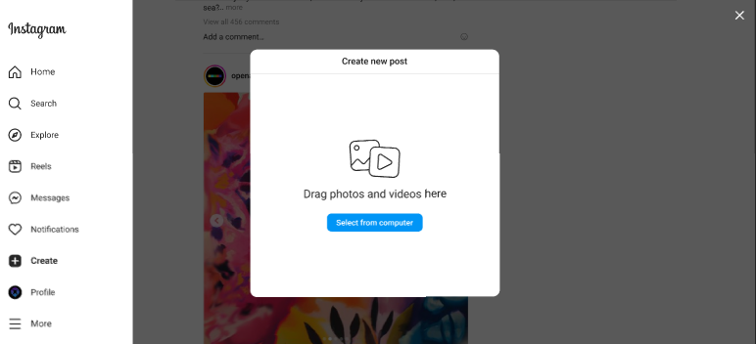

**Figure 3.3-1**: Screen Design of Create Post

**Table 3.3-1: Screen Definition**

| **#** | **Field Name** | **Type** | **Mandatory** | **Max Length** | **Description** |
| --- | --- | --- | --- | --- | --- |
| 1 | Select from Computer | Button | Yes | N/A | Import image or video from system |

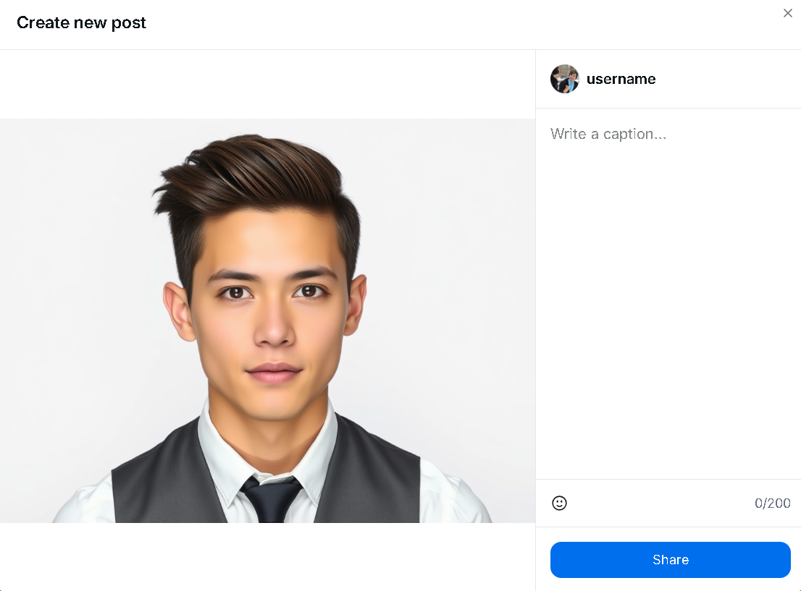

**Figure 3.2-2**: Screen Design of post sharing

| **#** | **Field Name** | **Type** | **Mandatory** | **Max Length** | **Description** |
| --- | --- | --- | --- | --- | --- |
| 1 | Image | image | Yes | N/A | Display image of post. Can click to image to tag other user |
| 2 | Write a caption | text area | Yes | 255 | Write the caption of the post |
| 3 | Emoji icon | button | No | N/A | Choose emoji for the caption for more beautiful caption |
| 4 | Share | button | Yes | N/A | Submit to create a new post |

**3.3.1.2 Use Case Description**

| **Use Case ID** | | **CM-01** | **Use Case Name** | | **Create Post** | |
| --- | --- | --- | --- | --- | --- | --- |
| **Author** | | **SonDH** | **Version** | **1.0** | **Date** | **15/06/2025** |
| **Actor** | | User | | | | |
| **Description** | | This use case describes how a user creates and publishes a new post that includes an image or video and an optional caption. The post becomes visible on the user's profile and appears in the feed of their followers. | | | | |
| **Precondition** | | PRE-01: The user is logged into the system.  PRE-02: The user's account is active. | | | | |
| **Trigger** | | TRG-01: The user chooses to create a new post from within the application. | | | | |
| **Post-Condition** | | POS-01: The new post is published and visible in the user's profile and the followers' feeds..  POS-02: No changes are made if the user cancels or an error occurs. | | | | |
| **Main flows** | | | | | | |
| ***Step*** | ***Actor*** | ***Action*** | | | | |
| *1* | User | Selects the option to create a new post. | | | | |
| *2* | System | Displays a screen allowing the user to create a post. | | | | |
| *3* | User | Selects a media file (such as an image or video) from their device | | | | |
| *4* | User | Enters an optional caption to describe the post. | | | | |
| *5* | User | Chooses to share the post | | | | |
| *6* | System | Checks that the uploaded file and caption meet the rules. | | | | |
| *7* | System | Publishes the post and confirms that it has been shared | | | | |

**Alternative flows**

| **AT1** | User Cancels Before Sharing | |
| --- | --- | --- |
| **Sub step** | **Actor** | **Action** |
| 1.1 | User | Click the "Cancel" or "Back" button. |
| 1.2 | System | Discards the form data and returns the user to the previous screen. The use case ends. |

| **AT2** | Invalid Media File | |
| --- | --- | --- |
| **Sub step** | **Actor** | **Action** |
| 6.1 | System | Informs the user that the file is invalid (e.g., wrong type or too large). |
| 6.2 | User | Prompted to select a different file |

| **AT3** | Caption Too Long | |
| --- | --- | --- |
| **Sub step** | **Actor** | **Action** |
| 6.1 | Midia | Notifies the user that the caption is too long. |
| 6.2 | User | May revise the caption and try again. |

| **AT4** | System Error | |
| --- | --- | --- |
| **Sub step** | **Actor** | **Action** |
| 6.1 | Midia | Shows a message that the post could not be shared and advises the user to try again later. |

***Business Rules***

| **#** | **Rule Description** |
| --- | --- |
| BR-10 | A post must include one media file (image or video). |
| BR-11 | Only the following file formats are accepted: JPG, JPEG, PNG (images); MP4 (videos). |
| BR-12 | The maximum file size is 10MB for images and 100MB for videos. |
| BR-13 | Captions are optional but must not exceed 2,200 characters. |

### 

#### 3.3.2 View Post Details

##### 3.3.2.1 Screen Mock-up

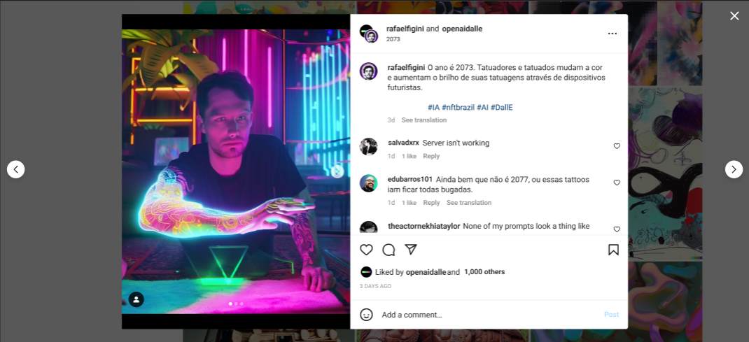

**Figure 3.3-2**: Screen Design of Post Details

**Table 3.3-2: Screen Definition**

| **#** | **Field Name** | **Type** | **Mandatory** | **Max Length** | **Description** |
| --- | --- | --- | --- | --- | --- |
| 1 | Image | Image | Yes |  | Display images of a post |
| 2 | Next Image | Button | Yes |  | Allow users to move to next image of this post if there are more than 2 images |
| 3 | Previous Image | Button | Yes |  | Allow users to move to previous image of this post if there are more than 2 images |
| 4 | Avatar | Image | Yes |  | Display users’ avatars |
| 5 | Username | Label | Yes |  | Display users’ username |
| 6 | Full name | Label | Yes |  | Display the current user’s full name |
| 7 | Post time | Label | Yes |  | Display how long this post was created |
| 8 | Post content | Label | Yes |  | Display the description of image that users import in a post |
| 9 | Comment field | Label | No |  | Display the comments of other users |
| 10 | Comments time | Label | Yes |  | Display how long this comment was posted |
| 11 | Comments like | Icon | Yes |  | Display how many likes that this comment has |
| 12 | Reply | Link | Yes |  | Allow users to answer someone’s comment |
| 13 | Like icon | Icon | Yes |  | Allow users to like comments |
| 14 | Comment icon | Icon | Yes |  | Allow users to create a comment |
| 15 | Share icon | Icon | Yes |  | Allow users to share this post |
| 16 | Number of liked | Label | Yes |  | Display the number of liked that users’ post have and their friends’ username |
| 17 | Feeling icon | Icon | Yes |  | Allow users to add some icons in their comment |
| 18 | Add a comment | Text | Yes |  | Allow users to type their comment |
| 19 | Post | Button | Yes |  | Allow users to post their comment |

**3.3.2.2 Use Case Description**

| **Use Case ID** | | **CM-02** | **Use Case Name** | | **Post Details** | |
| --- | --- | --- | --- | --- | --- | --- |
| **Author** | | **SonDH** | **Version** | **1.0** | **Date** | **15/06/2025** |
| **Actor** | | Registered User | | | | |
| **Description** | | This use case describes how a registered user can view the details of a post. The user can see the post's content and engage with it through actions such as liking, commenting, or saving. Only posts that the user has permission to view will be accessible. | | | | |
| **Precondition** | | PRE-01: The user is logged into the system.  PRE-02: The post exists and is accessible to the user. | | | | |
| **Trigger** | | TRG-01: The user clicks on a post or selects an option to view more comments from any section of the application | | | | |
| **Post-Condition** | | POS-01: (Success) The user sees the full details of the selected post..  POS-02: (Failure) An error message is shown if the post cannot be displayed. The user remains on the previous screen. | | | | |
| **Main flows** | | | | | | |
| ***Step*** | ***Actor*** | ***Action*** | | | | |
| *1* | User | Selects a post they wish to view in detail. | | | | |
| *2* | System | Checks the availability and permissions for the selected post. | | | | |
| *3* | System | Displays the full post: the media content (image or video), the author’s name and profile image ,the caption, if provided, the number of likes, the list of comments, options to like, comment, save, or share | | | | |

**Alternative flows**

| **AT1** | Liking a Post | |
| --- | --- | --- |
| **Sub step** | **Actor** | **Action** |
| 3.1 | User | Clicks the like button |
| 3.2 | System | Updates the post’s like status for the user and adjusts the like count. |

| **AT2** | Commenting on a Post | |
| --- | --- | --- |
| **Sub step** | **Actor** | **Action** |
| 3.1 | User | Enter a comment and submit it. |
| 3.2 | System | Adds the comment to the post and updates the comment section. |

| **AT3** | Saving a Post | |
| --- | --- | --- |
| **Sub step** | **Actor** | **Action** |
| 3.1 | User | Click the save button |
| 3.2 | System | Updates the saved status of the post for the user |

| **AT4** | Post Owner Options (Edit/Delete) | |
| --- | --- | --- |
| **Sub step** | **Actor** | **Action** |
| 3.1 | User | Selects the option menu and chooses to edit or delete the post. |
| 3.2 | System | Starts the appropriate process (e.g., editing or confirming deletion). |

| **AT5** | Closing Post View | |
| --- | --- | --- |
| **Sub step** | **Actor** | **Action** |
| 3.1 | User | Closes the post detail view. |
| 3.2 | System | Returns the user to the previous screen. |

| **AT6** | Post Not Available | |
| --- | --- | --- |
| **Sub step** | **Actor** | **Action** |
| 2.1 | User | Shows a message indicating the post is unavailable |

***Business Rules***

| **#** | **Rule Description** |
| --- | --- |
| BR-55 | Only the author can see the "Edit" and "Delete" options for their post. |
| BR-56 | A user can like or unlike a post, but only once at a time. |
| BR-57 | Comments are shown in order from oldest to newest. |

### 3.4 User Settings

#### **3.4.1 User Settings**

##### 3.4.1.1 Screen Mock-up

##### 

**Figure 3-4**: Screen Design of User Settings

**Table 3-4: Screen Definition**

| **#** | **Field Name** | **Type** | **Mandatory** | **Max Length** | **Description** |
| --- | --- | --- | --- | --- | --- |
| 1 | Name | Text | Yes |  | Display real name of user who has logged in |
| 2 | Username | Text | Yes |  | Display username of account which has logged in |
| 3 | Website | Text | No |  | Display users’ website link. This field can be edited if users are using a mobile app and optional |
| 4 | Bio | Text | No |  | Display short biography of users. Users can only type about 150 characters. This field is optional |
| 5 | Email | Text | Yes |  | Display user’s email. Email must follow the format <name>@<domain>. This field cannot be edited |
| 6 | Phone number | Text | Yes | 11 | Display user’s phone number. Phone number must contain 11 digits. |
| 7 | Gender | Dropdown box | Yes |  | Display the user's gender. This field contains Male, Female and Prefer not to say |
| 8 | Show account suggestions | Checkbox | No |  | Allow users to see similar account suggestions on their profiles |
| 9 | Learn more | Link | Yes |  | Display the link that navigates to the information about changing username policies |
| 10 | Change profile photo | Link | Yes |  | Display the link that navigates to change profile photo screen |
| 11 | Submit | Button | Yes |  | Allow to save all changes |
| 12 | Temporarily deactivate my account | Link | Yes |  | Allow users to deactivate their account if they want |
| 13 | Edit profile | List item | Yes |  | Allow users to open the edit profile box. They can change their information stored in the system |

**3.4.1.2 Use Case Description**

| **Use Case ID** | | **US-01** | **Use Case Name** | | **User Settings** | |
| --- | --- | --- | --- | --- | --- | --- |
| **Author** | | **HoanTX** | **Version** | **1.0** | **Date** | **13/06/2025** |
| **Actor** | | Registered User | | | | |
| **Description** | | This use case describes how a registered user accesses the User Settings page to view or update their personal information. | | | | |
| **Precondition** | | PRE-01: The user has an active and unbanned account.  PRE-02: The user has a stable internet connection.  PRE-03: The user accesses the website via the correct web address.  PRE-04: The user is already signed in. | | | | |
| **Trigger** | | TRG-01: The user clicks the settings icon located in the header of the website. | | | | |
| **Post-Condition** | | POS-01: The system displays the user's personal information and profile picture.  POS-02: Editable fields and available actions (e.g., Save, Deactivate Account) are visible and ready for interaction. | | | | |
| **Main flows** | | | | | | |
| ***Step*** | ***Actor*** | ***Action*** | | | | |
| *1* | The User | Open a web browser and enters the website address. | | | | |
| *2* | Midia | Display the homepage with a settings icon in the bottom-right corner. | | | | |
| *3* | The User | Click the settings icon. | | | | |
| *4* | Midia | Display the User Settings page, showing the user's profile information and available options. | | | | |

**Alternative flows**

| **AT1** | Users click the “Learn more” link next to the Username field. | |
| --- | --- | --- |
| **Sub step** | **Actor** | **Action** |
| 1.1 | Midia | Opens a new page displaying the platform’s username policies. |
|  | | |
| **AT2** | Users click the “Temporarily deactivate my account” link. | |
| **Sub step** | **Actor** | **Action** |
| 2.1 | Midia | Shows a confirmation message asking the user to confirm their action. |
| 2.2 | User | Chooses either “OK” or “Cancel”. |
| 2.3 | Midia | **AT2.3.1 Users clicks the Ok button**   * Ends the session, clears login state, and redirects to the login page.   **AT2.3.2 Users clicks the Cancel button  -** Closes the confirmation message and returns to the settings page. |

***Business Rules***

| **#** | **Rule Description** |
| --- | --- |
| BR-14 | The phone number must contain exactly 11 digits and must be valid. |
| BR-15 | The username must be unique within the system. |

### 3.5 Follow System

#### **3.5.1 Follow Suggestions**

##### 3.5.1.1 Screen Mock-up

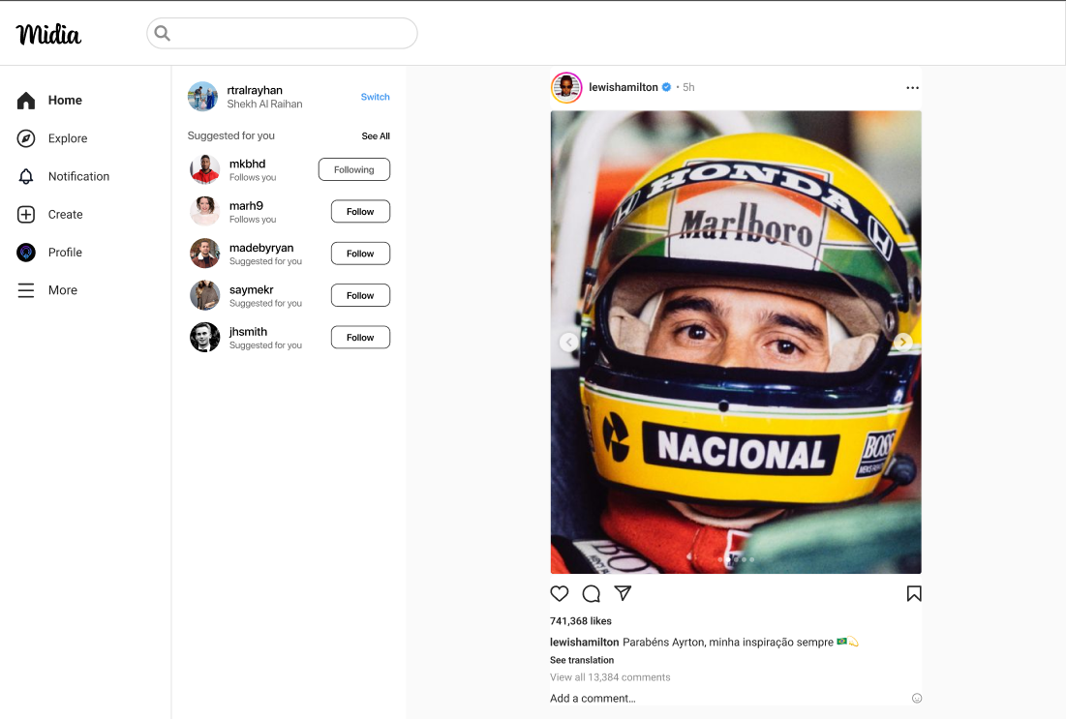

**Figure 3-5**: Screen Design of Follow Suggestions

**Table 3-4: Screen Definition**

| **#** | **Field Name** | **Type** | **Mandatory** | **Max Length** | **Description** |
| --- | --- | --- | --- | --- | --- |
| 1 | Username | Label | Yes |  | Display usernames of accounts. |
| 2 | Full name | Label | Yes |  | Display the full name of user who is using the website |
| 3 | Avatar | Image | Yes |  | Display accounts’ avatars |
| 4 | Follows you/Suggested for you | Label | Yes |  | Displays a label next to another user's name in lists or search results.  **Follows you**: Indicates that the user is currently following you. Helps you quickly identify mutual connections.  **Suggested for you**: Shown for users that Instagram recommends based on your behavior, interests, or mutual connections. These users are not necessarily following you. |
| 5 | Switch | Link | Yes |  | Allow users to use another saved account or login with unsaved account |
| 6 | See All | Link | Yes |  | Navigate to screen that list all accounts that users can follow |
| 7 | Following/Follow | Button | Yes |  | Allow users to start follow or cancel follow other accounts  **Follow:** Displayed when the user *has not followed* the account. Clicking it sends the following request.  **Following**: Displayed when the user *is currently following* the account. Clicking it may open an "Unfollow" option or directly trigger the unfollow action (depending on the design). |

##### 3.5.1.2 Use Case Description

| **Use Case ID** | | **FS-01** | **Use Case Name** | | **Follow Suggestions** | |
| --- | --- | --- | --- | --- | --- | --- |
| **Author** | | **HoanTX** | **Version** | **1.0** | **Date** | **15/06/2025** |
| **Actor** | | Registered User | | | | |
| **Description** | | Displays a list of accounts suggested by the system for the user to follow, based on interests, mutual connections, previous interactions, or for newly created accounts. | | | | |
| **Precondition** | | PRE-01: Users have unbanned accounts  PRE-02: Users have a stable Internet connection  PRE-03: Users access the website with the correct URL  PRE-04: Users have signed in successfully | | | | |
| **Trigger** | | TRG-01: Users access the website | | | | |
| **Post-Condition** | | POS-01: Users avatar, username and fullname are displayed  POS-02: List of 5 accounts with labels, buttons are rendered and ready to interact | | | | |
| **Main flows** | | | | | | |
| ***Step*** | ***Actor*** | ***Action*** | | | | |
| *1* | User | Type URL into location field of internet browser and then press enter | | | | |
| *2* | Midia | Display Home page with suggestions in the right of left sidebar | | | | |

**Alternative flows**

| **AT1** | Users click the “Switch” link | |
| --- | --- | --- |
| **Sub step** | **Actor** | **Action** |
| 1.1 | Midia | Navigate to Login screen |
|  | | |
| **AT2** | Users click the “See all” link | |
| **Sub step** | **Actor** | **Action** |
| 2.1 | Midia | Navigate to explore users screen |
|  | | |
| **AT3** | Users click the Follow/Following button | |
| 3.1 | Midia | **AT3.1 Users click the “Follow” button**   * Change button from “Follow” to “Following” * Change label from “Suggested for you” to “Follows you” * Add this account to the followings list of current account   **AT3.2 Users click the “Following” button**   * Change button from “Following” to “Follow” * Change label from “Follows you” to “Suggested for you” * Remove this account from the followings list of current account |

***Business Rules***

| **#** | **Rule Description** |
| --- | --- |
| BR-16 | List of suggestions must be limited in 5 accounts |

### 3.6 Profile Management

#### 3.6.1 Profile page

##### 3.6.1.1 Screen Mock-up

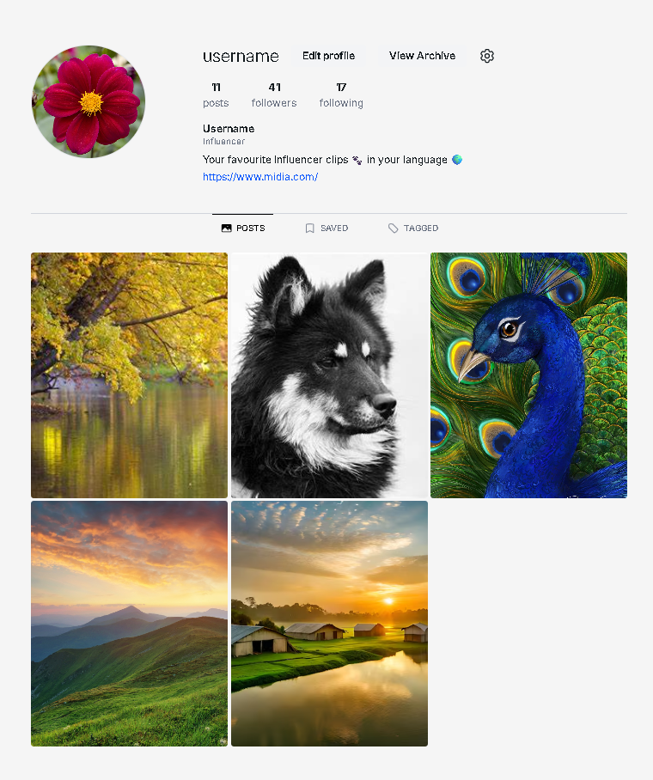

**Figure 3-5**: Screen Design of Follow Suggestions

**Table 3-6: Screen Definition**

| **#** | **Field Name** | **Type** | **Mandatory** | **Max Length** | **Description** |
| --- | --- | --- | --- | --- | --- |
| 1 | Username | Label | Yes | N/A | Display usernames of accounts. |
| 2 | Edit profile | Button | No | N/A | Navigate to edit profile page |
| 3 | Avatar | Image | Yes | N/A | Display accounts’ avatars |
| 4 | Number of posts | Text | Yes | 10 | Display number of posts of that user |
| 5 | Number of followers | Text | Yes | 10 | Display number of followers of that user |
| 6 | Number of following | Text | Yes | 10 | Display number of following user of that user |
| 7 | Description | Text | No | 100 | Display the description of that user profile |
| 8 | Link to other page | Text | No | 100 | Display the link of other profile page |
| 9 | Post navigation | Link | No | N/A | Display all the post of that user |
| 10 | Saved navigation | Link | No | N/A | Display all the saved post of that user |
| 11 | Tagged navigation | Link | No | N/A | Display all the post of that user that been tagged by others |
| 12 | Image Posts | Image | Yes | N/A | Display the image of the posts. When hover, show the number of comment and like. When click, show modal of image, comment and number of like. User can interact inside that modal |
| 13 | Setting icon | Button | No | N/A | Navigate user to User Setting screen page |

##### 3.6.1.2 Use Case Description

| **Use Case ID** | | **PM-01** | **Use Case Name** | | **Profile page** | |
| --- | --- | --- | --- | --- | --- | --- |
| **Author** | | **SonDH** | **Version** | **1.0** | **Date** | **15/06/2025** |
| **Actor** | | User | | | | |
| **Description** | | Enables the user to view their personal profile, including username, description, activity statistics, and account interactions. The user can also update personal information, view and manage posts, comments, followers, and followings. | | | | |
| **Precondition** | | PRE-01: The user is logged in.  PRE-02: The chosen profile exists. | | | | |
| **Trigger** | | TRG-01: The user selects their profile picture or username to view the profile. | | | | |
| **Post-Condition** | | POS-01: The profile page is displayed to the user.  POS-02: Any updates made by the user appear immediately on the profile. | | | | |
| **Main flows** | | | | | | |
| ***Step*** | ***Actor*** | ***Action*** | | | | |
| *1* | User | Selects their profile via the header or a post. | | | | |
| *2* | System | Displays the user's profile with personal details: username, bio, post count, followers, following, number of likes, and comments. | | | | |
| *3* | User | Has the option to edit their profile, view individual posts, or access further settings. | | | | |
| *4* | System | Reflects any changes or updates made by the user. | | | | |

**Alternative flows**

| **AT1** | At the step 1, user click into user profile that been deleted or change status to “LOCK” | |
| --- | --- | --- |
| **Sub step** | **Actor** | **Action** |
| 1.1 | Client | Show status 404 message “User not found” |

***Business Rules***

| **#** | **Rule Description** |
| --- | --- |
| BR-17 | Phone number must have 11 digits and is existed |
| BR-18 | Username must be unique |

#### **3.6.2 Edit Profile**

##### 3.6.2.1 Screen Mock-up

##### 

**Figure 3-6.2.1**: Screen Design of Edit Profile

**Table 3-6.2.1: Screen Definition**

| **#** | **Field Name** | **Type** | **Mandatory** | **Max Length** | **Description** |
| --- | --- | --- | --- | --- | --- |
| 1 | Avatar | Image | Yes |  | Display accounts’ avatars |
| 2 | Username | Text | Yes |  | Display username of account which has logged in |
| 3 | Full name | Label | Yes |  | Display the full name of user who is using the website |
| 4 | Change photo | Button |  |  | Allow users to replace the old avatar in the popup screen |
| 5 | Website | Text | No |  | Display users’ website link. This field can be edited if users are using a mobile app and optional |
| 6 | Bio | Text | No |  | Display short biography of users. Users can only type about 150 characters. This field is optional |
| 7 | Gender | Dropdown box | Yes |  | Display the user's gender. This field contains Male, Female and Prefer not to say |
| 8 | Show account suggestions | Switch | No |  | Allow users to see similar account suggestions on their profiles |
| 9 | Submit | Button | Yes |  | Allow to save all changes |

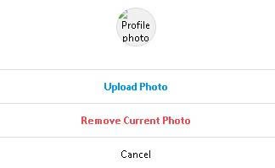

**Figure 3-6.2.2**: Screen Design of Change photo popup screen

**Table 3-6.2.2: Screen Definition**

| **#** | **Field Name** | **Type** | **Mandatory** | **Max Length** | **Description** |
| --- | --- | --- | --- | --- | --- |
| 1 | Profile photo | Image | Yes |  | Display accounts’ avatars |
| 2 | Upload photo | Button | Yes |  | Allow users to upload a new photo |
| 3 | Remove current photo | Button | Yes |  | Allow users to remove the current avatar |
| 4 | Cancel | Button | Yes |  | Allow users to cancel all changes and go back to previous screen |

##### 3.6.2.2 Use Case Description

| **Use Case ID** | | **PM-02** | **Use Case Name** | | **Edit Profile** | |
| --- | --- | --- | --- | --- | --- | --- |
| **Author** | | **HoanTX** | **Version** | **1.0** | **Date** | **15/06/2025** |
| **Actor** | | Registered User | | | | |
| **Description** | | This use case describes how a registered user updates their personal profile information, including website link, bio, gender, visibility of account suggestions, and profile picture. | | | | |
| **Precondition** | | PRE-01: The user has an active and unbanned account.  PRE-02: The user has a stable internet connection.  PRE-03: The user accesses the website using the correct address.  PRE-04: The user is already signed in. | | | | |
| **Trigger** | | TRG-01: The user clicks the “Edit Profile” button on their profile page. | | | | |
| **Post-Condition** | | POS-01: The user’s current profile details, including profile picture and editable fields, are displayed.  POS-02: The interface allows the user to make changes and save them. | | | | |
| **Main flows** | | | | | | |
| ***Step*** | ***Actor*** | ***Action*** | | | | |
| *1* | The User | Opens a web browser and enters the website address. | | | | |
| *2* | Midia | Display Home page | | | | |
| *3* | The User | Selects the Profile option from the sidebar. | | | | |
| *4* | Midia | Displays the user's profile page with an “Edit Profile” button. | | | | |
| *5* | The User | Click the “Edit profile” button | | | | |
| *6* | Midia | Displays the Edit Profile screen showing editable fields such as website, bio, gender, and account suggestion preferences. | | | | |

**Alternative flows**

| **AT1** | Change Profile Picture | |
| --- | --- | --- |
| **Sub step** | **Actor** | **Action** |
| 1.1 | The User | Click the “Change Photo” button. |
| 1.2 | Midia | Displays a pop-up with options to upload, remove, or cancel. |
| 1.3a | The User | Selects “Upload Photo”, chooses an image, and confirms. |
| 1.4a | Midia | Updates the user’s profile picture. |
| 1.3b | The User | Selects “Remove Current Photo” and confirms removal. |
| 1.4b | Midia | Removes the profile picture if confirmed, or cancels the operation. |
| 1.3c | The User | Selects “Cancel”. |
| 1.4c | Midia | Closes the change photo popup without making changes. |

***Business Rules***

| **#** | **Rule Description** |
| --- | --- |
| BR-19 | The uploaded image must not exceed 5MB in size. |
| BR-20 | Accepted image formats are JPG, PNG, or WEBP. |

### 

### 3.7 Account Management

#### **3.7.1 Login**

##### 3.7.1.1 Screen Mock-up

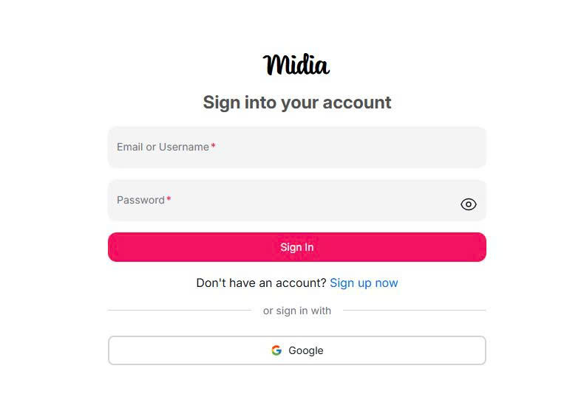

**Figure 3-7.1**: Screen Design of Follow Suggestions

**Table 3-7.1: Screen Definition**

| **#** | **Field Name** | **Type** | **Mandatory** | **Max Length** | **Description** |
| --- | --- | --- | --- | --- | --- |
| 1 | Username | Label | Yes | N/A | Display usernames of accounts. |
| 2 | Password | Label | Yes | N/A | Display password of accounts. |
| 3 | Sign In | Button | No | N/A |  |
| 4 | Sign up now | Link | No | N/A | Navigate to sign up page. |
| 5 | Google | Button | No | N/A | Sign in via google. |

##### 3.7.1.2 Use Case Description

| **Use Case ID** | | **AM-01** | **Use Case Name** | | **Login** | |
| --- | --- | --- | --- | --- | --- | --- |
| **Author** | | **HoangMH** | **Version** | **1.0** | **Date** | **15/06/2025** |
| **Actor** | | Guest | | | | |
| **Description** | | This use case describes how a guest accesses their account on the website by providing login credentials or using a third-party login option (Google). | | | | |
| **Precondition** | | PRE-01: The user has already registered an account or owns a Google account.  PRE-02: The user is currently logged out. | | | | |
| **Trigger** | | TRG-01: The user accesses the website and selects the login option. | | | | |
| **Post-Condition** | | POS-01: The user successfully accesses their account and is taken to the home page.  POS-02: The system recognizes the user as logged in for future interactions. | | | | |
| **Main flows** | | | | | | |
| ***Step*** | ***Actor*** | ***Action*** | | | | |
| *1* | User | Click the "Login" button on the website. | | | | |
| *2* | Client | The system displays the login page with options to log in using credentials or via Google. | | | | |
| *3* | User | The user enters their username and password, then submits the form. | | | | |
| *4* | System | The system checks the provided information. | | | | |
| *5* | System | If the information is correct, the system logs the user in and shows the home page. | | | | |

**Alternative flows**

| **AT1** | Login using Google | |
| --- | --- | --- |
| **Sub step** | **Actor** | **Action** |
| 1.1 | User | Selects the "Login with Google" option. |
| 1.2 | System | Directs the user to the Google login page. |
| 1.3 | User | Completes the login process on Google. |
| 1.4 | System | Confirms the user’s identity and logs them in. If this is the first login, a new account is created. |
| 1.5 | System | Takes the user to the home page. |

| **AT2** | Invalid Credentials | |
| --- | --- | --- |
| **Sub step** | **Actor** | **Action** |
| 2.1 | User | Enter incorrect username or password. |
| 2.2 | Client | Inform the user that the information is invalid and prompts them to try again. |

| **AT3** | Account Locked or Banned | |
| --- | --- | --- |
| **Sub step** | **Actor** | **Action** |
| 3.1 | User | Submits login information. |
| 3.2 | System | Detects the account is locked or banned |
| 3.3 | System | Notifies the user that they cannot log in due to account status |

***Business Rules***

| **#** | **Rule Description** |
| --- | --- |
| BR-21 | Each username must be unique, and passwords must meet security requirements. |
| BR-22 | Only users with active accounts are allowed to log in. |
| BR-23 | Google login is only possible if the user’s Google account is verified. |

#### **3.7.2 Register**

##### 3.7.2.1 Screen Mock-up

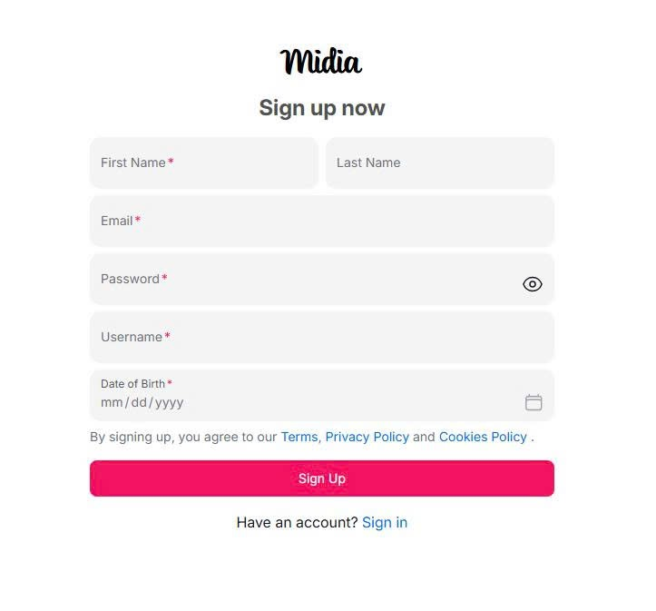

**Figure 3-7.2**: Screen Design of Register

**Table 3-7.2: Screen Definition**

| **#** | **Field Name** | **Type** | **Mandatory** | **Max Length** | **Description** |
| --- | --- | --- | --- | --- | --- |
| 1 | First Name | Input | Yes | 30 | Enter user’s first name |
| 2 | Last Name | Input | No | 30 | Enter user’s last name |
| 3 | Email | Input | Yes | 30 | Enter user’s email |
| 4 | Password | Input | Yes | 30 | Enter user’s password |
| 5 | Username | Input | Yes | 20 | Enter user’s username |
| 6 | Date of birth | Date | Yes | N/A | Choose user’s date of birth in calendar |
| 7 | Sign up | Button | Yes | N/A | Submit button to create a new account |
| 8 | Sign in | Button | No | N/A | Navigate user to login page |

##### 3.7.2.2 Use Case Description

| **Use Case ID** | | **AM-02** | **Use Case Name** | | **Register** | |
| --- | --- | --- | --- | --- | --- | --- |
| **Author** | | **HoangMH** | **Version** | **1.0** | **Date** | **15/06/2025** |
| **Actor** | | Guest | | | | |
| **Description** | | This use case describes how a guest creates a new account by providing required personal information. | | | | |
| **Precondition** | | PRE-01: The user is currently not signed in. | | | | |
| **Trigger** | | TRG-01: The user selects the “Sign up” option on the website. | | | | |
| **Post-Condition** | | POS-01: A new account is created for the user.  POS-02: The user is directed to the login screen or home page. | | | | |
| **Main flows** | | | | | | |
| ***Step*** | ***Actor*** | ***Action*** | | | | |
| *1* | User | Selects the “Sign up” option | | | | |
| *2* | System | Shows the registration form | | | | |
| *3* | User | Enters the required information (e.g., full name, email, username, password). | | | | |
| *4* | System | If everything is valid, the system creates a new user account. | | | | |
| *5* | System | Confirms successful registration and guides the user to the login screen or home page. | | | | |

**Alternative flows**

| **AT1** | Username or Email Already Exists | |
| --- | --- | --- |
| **Sub step** | **Actor** | **Action** |
| 1.1 | User | Submit the registration form. |
| 1.2 | System | Find that the username or email is already in use. |
| 1.3 | System | Inform the user that the username or email is already taken and asks for a different one |

***Business Rules***

| **#** | **Rule Description** |
| --- | --- |
| BR-24 | Each username and email must be unique. |
| BR-25 | The password must be at least 8 characters long. |

#### **3.7.3 Forgot password**

##### 3.7.3.1 Screen Mock-up

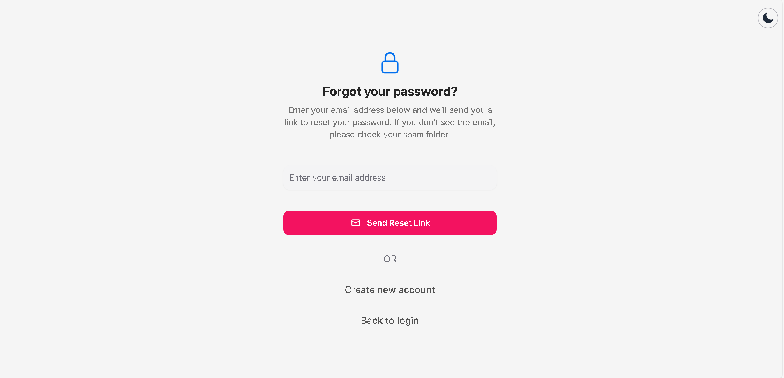

**Figure 3-7.3.1**: Screen Design of forgot password

**Table 3-7.3.1: Screen Definition**

| **#** | **Field Name** | **Type** | **Mandatory** | **Max Length** | **Description** |
| --- | --- | --- | --- | --- | --- |
| 1 | Theme Switcher | Button | No | N/A | Switch the theme of the system |
| 2 | Email address | Input | Yes | 30 | Enter user’s email |
| 3 | Send Reset Link | Button | Yes | N/A | Confirm email and send reset password URL |
| 4 | Create new account | Link | No | N/A | DIrect user to register page |
| 5 | Back to login | Link | No | N/A | DIrect user to login page |

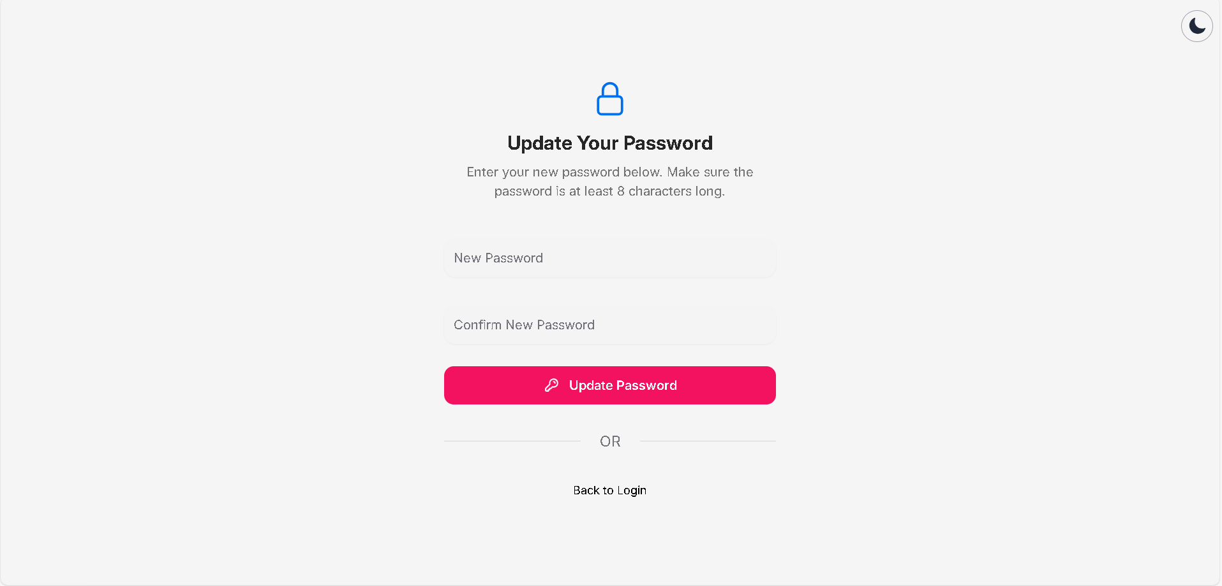

**Figure 3-7.3.1**: Screen Design of update password

**Table 3-7.3.2: Screen Definition**

| **#** | **Field Name** | **Type** | **Mandatory** | **Max Length** | **Description** |
| --- | --- | --- | --- | --- | --- |
| 1 | Theme Switcher | Button | No | N/A | Switch the theme of the system |
| 2 | New password | Input | Yes | 8 | Enter user's new password |
| 3 | Confirm new password | Input | Yes | 8 | Enter user's confirm new passwordL |
| 4 | Update password | Button | Yes | N/A | Confirm user to update the new password |
| 5 | Back to login | Link | No | N/A | DIrect user to login page |

##### 3.7.2.2 Use Case Description

| **Use Case ID** | | **AM-03** | **Use Case Name** | | **Forgot Password** | |
| --- | --- | --- | --- | --- | --- | --- |
| **Author** | | **SonDH** | **Version** | **1.0** | **Date** | **15/06/2025** |
| **Actor** | | Guest | | | | |
| **Description** | | This use case describes how a user can reset their password by providing their email address. If the email is valid and belongs to a verified account, the user will receive a link to create a new password. | | | | |
| **Precondition** | | PRE-01: The account’s email address has been verified.  PRE-02: The user has an existing account. | | | | |
| **Trigger** | | TRG-01: User clicks “Forgot password?” on the login screen. | | | | |
| **Post-Condition** | | POS-01: (Success) A message confirms that a reset link has been sent to the user’s email.  POS-02: (Failure) The system informs the user if the process cannot be completed. | | | | |
| **Main flows** | | | | | | |
| ***Step*** | ***Actor*** | ***Action*** | | | | |
| *1* | User | Select the “Forgot password?” option on the login screen | | | | |
| *2* | System | Shows a form asking the user to enter their email address. | | | | |
| *3* | User | Enters their email and submits the form | | | | |
| *4* | System | Checks whether the email belongs to a verified account. | | | | |
| *5* | System | Sends a password reset link to the user’s email. | | | | |
| *6* | System | Display a message confirming that the reset link has been sent | | | | |
| *7* | User | User click reset link in their email | | | | |
| *8* | System | Shows a screen that allows the user to enter and confirm a new password. | | | | |
| *9* | User | Enters new password and confirms it | | | | |
| *10* | System | Verifies the information and updates the user’s password. | | | | |
| *11* | System | Displays a success message and guides the user to log in with the new password. | | | | |

**Alternative flows**

| **AT1** | Email Not Found | |
| --- | --- | --- |
| **Sub step** | **Actor** | **Action** |
| 1.1 | System | informs the user that the email is not associated with any account. |
| 1.2 | System | prompts the user to re-enter or try a different email. |

| **AT2** | Expired or Invalid Link | |
| --- | --- | --- |
| **Sub step** | **Actor** | **Action** |
| 2.1 | System | Informs the user that the link is invalid or expired. |
| 2.2 | Client | Offers an option to request a new link. |

| **AT3** | Passwords Do Not Match | |
| --- | --- | --- |
| **Sub step** | **Actor** | **Action** |
| 2.1 | System | Shows an error message and asks the user to try again |

***Business Rules***

| **#** | **Rule Description** |
| --- | --- |
| BR-26 | The user must provide a valid and registered email address. |
| BR-27 | Each password reset link must be secure and unique. |
| BR-28 | The new password must meet security requirements (e.g., at least 8 characters, include both letters and numbers). |
| BR-29 | The new password and its confirmation must match exactly. |
| BR-30 | Only accounts with verified email addresses can reset their password. |

### 3.8 Home Features

#### **3.8.1** Landing h**ome page**

##### 3.8.1.1 Screen Mock-up

##### 

**Figure 3-8-1**: Screen Design of Home page

**Table 3-8: Screen Definition**

| **#** | **Field Name** | **Type** | **Mandatory** | **Max Length** | **Description** |
| --- | --- | --- | --- | --- | --- |
| 1 | Username | Text(Link) | Yes | 20 | The display name of the user who posted. Clickable to navigate to profile page. |
| 2 | Post image | Text | Yes | N/A | The main image of the post. |
| 3 | Post caption | Text | No | 200 | The description or caption of the post. |
| 4 | Like count | Integer | Yes | N/A | The number of likes for the post. |
| 5 | Comment input | Text Input | No | N/A | Input field where user can type a comment. |
| 6 | Comment link | Icon Button | No | N/A | Link to view all comments of the post. |
| 7 | Post timestamp | Dropdown box | Yes | N/A | Opens a dropdown menu with actions (e.g., report, share). |
| 8 | Follow button | Button | No | N/A | Button to follow the suggested user. |
| 9 | More Options (⋯) | Icon Button | No | N/A | Opens a dropdown menu with actions (e.g., report, share). |
| 10 | Suggested User Name | Link | Yes | 20 | Username of the suggested account to follow. |
| 11 | View all comment | Button | Yes | N/A | Opens the comment section to view all comments. |
| 12 | Reaction Icons | Icon Group | No | N/A | Icons for actions: like, comment, share. |
| 13 | Add a Comment Placeholder | Placeholder text | No | N/A | Placeholder text in the comment input, e.g. “Add a comment…” |
| 14 | Suggestions for You - Card | Card Group | No | N/A | Cards showing user suggestions with avatar, name, and follow button. |
| 15 | Navigation Menu | Button group | Yes | N/A | Sidebar with navigation: Home, Explore, Notification, Create, Profile, More. |
| 16 | Profile picture | Image button | Yes | N/A | Avatar image of the user. Clickable to view their profile. |

##### 3.8.1.2 Use Case Description

| **Use Case ID** | | **H-01** | **Use Case Name** | | **Home Page** | |
| --- | --- | --- | --- | --- | --- | --- |
| **Author** | | **KhanhNT** | **Version** | **1.0** | **Date** | **15/06/2025** |
| **Actor** | | Guest, User | | | | |
| **Description** | | This use case describes the behavior of the Home Page, where users can view posts, like them, comment, and interact with other users. It also includes suggested users to follow and navigation menu options. | | | | |
| **Precondition** | | PRE-01: Users have unbanned accounts  PRE-02: Users have a stable Internet connection  PRE-03: The user has successfully logged in.  PRE-04: Users have signed in successfully | | | | |
| **Trigger** | | TRG-01: The user signs in and is redirected to the Home Page. | | | | |
| **Post-Condition** | | POS-01: The Home Feed is displayed, showing posts from following users.  POS-02: All UI components such as post list, reaction icons, comment input, and sidebar navigation are rendered  POS-03: The user is able to interact with posts and navigate the app. | | | | |
| **Main flows** | | | | | | |
| ***Step*** | ***Actor*** | ***Action*** | | | | |
| *1* | User | Logs in successfully or navigates to home page via sidebar menu | | | | |
| *2* | System | Displays the Home Page with a feed of recent posts | | | | |
| *3* | System | For each post, display: Username (clickable), Profile Picture, Post Image, Caption, Like Count, Reaction Icons, Comment Input, Comment Link, Post Timestamp, More Options | | | | |
| *4* | User | Interacts with posts (like, comment, view comments, share, …) | | | | |
| *5* | System | Displays suggested users to follow in sidebar with: Avatar, Suggested Username, Follow Button | | | | |
| *6* | User | Click “Follow” button to follow a suggested user | | | | |
| *7* | System | Update follow status and suggests more users | | | | |
| *8* | User | Uses the Navigation Menu to switch to other sections (Explore, Notifications, Profile, etc.) | | | | |

**Alternative flows**

| **AT1** | User is a guest (not signed in) | |
| --- | --- | --- |
| **Sub step** | **Actor** | **Action** |
| 1.1 | Midia | displays a limited home page with login/register prompts and restricted interaction (no like/comment/post). |

***Business Rules***

| **#** | **Rule Description** |
| --- | --- |
| BR-31 | Users can only like or comment on a post if they are logged in |
| BR-32 | Each comment is limited to 200 characters |
| BR-33 | Username display is limited to 20 characters |
| BR-34 | "More Options" dropdown includes: Report Post, Share Post, Copy Link |
| BR-35 | Suggested users are based on similar interests, friends of friends, or system recommendation engine |

#### 

#### 3.8.2 Explore page

##### 3.8.1.1 Screen Mock-up

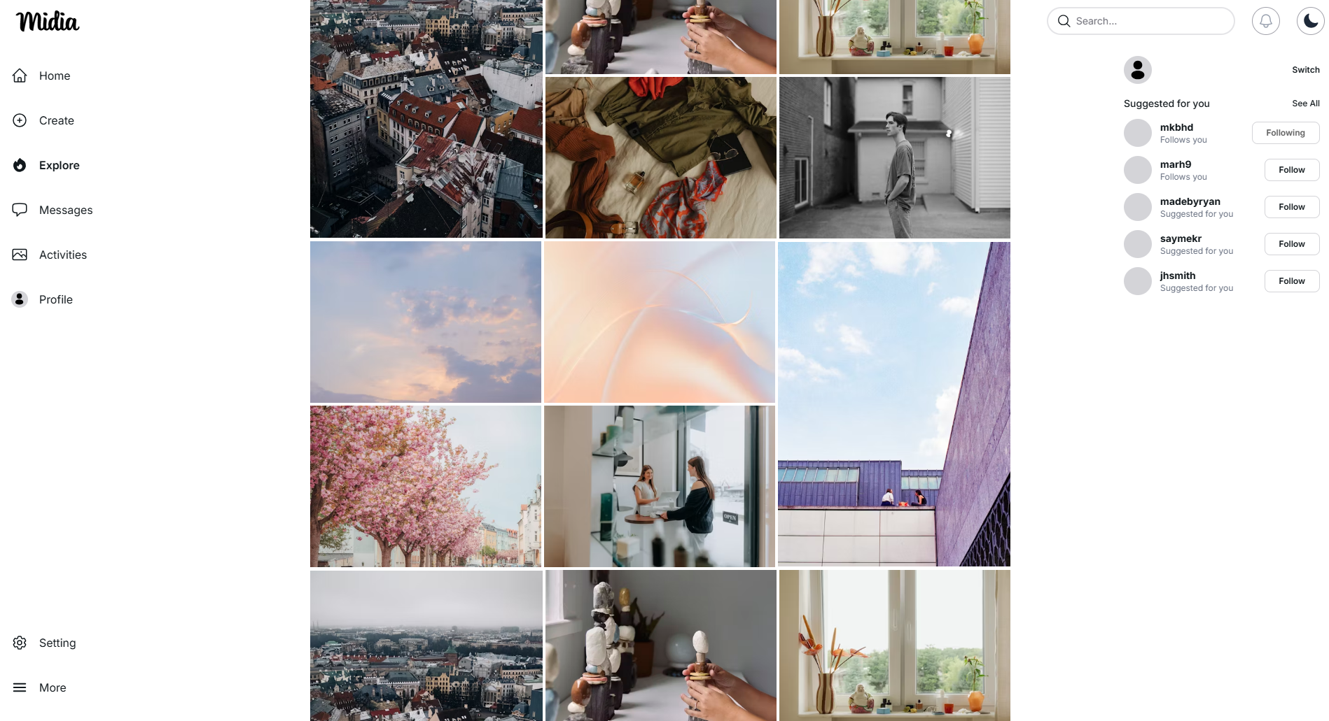

**Figure 3-8-2**: Screen Design of Explore page

**Table 3-8-2: Screen Definition**

| **#** | **Field Name** | **Type** | **Mandatory** | **Max Length** | **Description** |
| --- | --- | --- | --- | --- | --- |
| 1 | Post image | Text | Yes | N/A | The main image of the post. |

##### 3.8.1.2 Use Case Description

| **Use Case ID** | | **H-02** | **Use Case Name** | | **Explore Page** | |
| --- | --- | --- | --- | --- | --- | --- |
| **Author** | | **KhanhNT** | **Version** | **1.0** | **Date** | **15/06/2025** |
| **Actor** | | Guest, User | | | | |
| **Description** | | This use case describes the behavior of the Explore Page, where users can view the most popular posts worldwide. It also includes suggested users to follow and navigation menu options. | | | | |
| **Precondition** | | PRE-01: Users have unbanned accounts  PRE-02: Users have a stable Internet connection  PRE-03: The user has successfully logged in.  PRE-04: Users have signed in successfully | | | | |
| **Trigger** | | TRG-01: The user signs in and clicks the Explore icon. | | | | |
| **Post-Condition** | | POS-01: Explore Page is displayed, showing a list image of the most popular posts.  POS-02: All UI components such as post, sidebar navigation are rendered  POS-03: The user is able to interact with posts and navigate the app. | | | | |
| **Main flows** | | | | | | |
| ***Step*** | ***Actor*** | ***Action*** | | | | |
| *1* | User | Logs in successfully and navigates to explore page via sidebar menu | | | | |
| *2* | System | Displays the Explore Page with a list of popular posts | | | | |
| *3* | System | For each post, display image posts and allow users to click on. | | | | |
| *4* | User | Interacts with posts through post details modal (like, comment, view comments, share, …) | | | | |

**Alternative flows**

| **AT1** | User is a guest (not signed in) | |
| --- | --- | --- |
| **Sub step** | **Actor** | **Action** |
| 1.1 | Midia | displays a limited explore page with login/register prompts and restricted interaction (no like/comment/post). |

#### 3.8.2 Comment Section

##### 3.8.1.1 Screen Mock-up

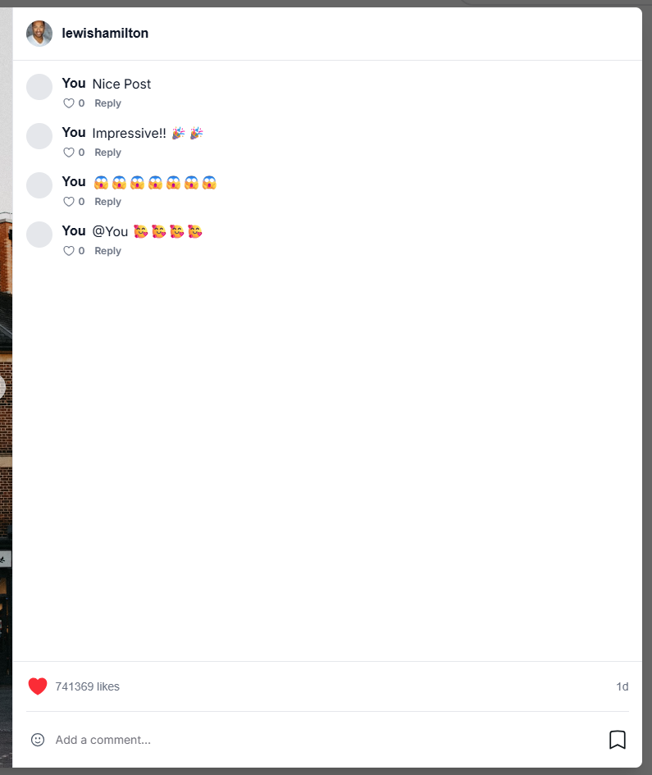

**Table 3-8-2: Screen Definition**

| **#** | **Field Name** | **Type** | **Mandatory** | **Max Length** | **Description** |
| --- | --- | --- | --- | --- | --- |
| 1 | Username | Text(Link) | Yes | 20 | The display name of the user who posted. Clickable to navigate to profile page. |
| 2 | Post caption | Text | No | 200 | The description or caption of the post. |
| 3 | Like count | Integer | Yes | N/A | The number of likes for the post. |
| 4 | Comment input | Text Input | No | N/A | Input field where user can type a comment. |
| 5 | Post timestamp | Text | Yes | N/A | Represent created time of post |
| 6 | Reaction Icons | Icon Group | No | N/A | Add Icons for comment |
| 7 | Add a Comment Placeholder | Placeholder text | No | N/A | Placeholder text in the comment input, e.g. “Add a comment…” |
| 8 | Heart icons | Button | No | N/A | like/unlike post |
| 9 | Bookmark | Button | No | N/A | Save post |

##### 3.8.1.2 Use Case Description

| **Use Case ID** | | **H-01** | **Use Case Name** | | **Home Page** | |
| --- | --- | --- | --- | --- | --- | --- |
| **Author** | | **KhanhNT** | **Version** | **1.0** | **Date** | **15/06/2025** |
| **Actor** | | Guest, User | | | | |
| **Description** | | This use case describes the behavior of the Comment Segment, where users can view others' comments, like them, reply, and add their own comments. | | | | |
| **Precondition** | | PRE-01: Users have unbanned accounts  PRE-02: Users have a stable Internet connection  PRE-03: The user has successfully logged in.  PRE-04: Users have signed in successfully | | | | |
| **Trigger** | | TRG-01: The user signs in and opens the Comment Section at Post Details Modal. | | | | |
| **Post-Condition** | | POS-01: Post can be accessible for users and is displayed, showing a comment segment with a list of comments from others users.  POS-02: The user is able to interact with posts and navigate the app. | | | | |
| **Main flows** | | | | | | |
| ***Step*** | ***Actor*** | ***Action*** | | | | |
| *1* | User | Logs in successfully and open any post details modal they can access | | | | |
| *2* | System | Displays the Post Modal with post content, author info and comment segment. | | | | |
| *3* | System | display: Username (clickable), Profile Picture, Post Image, Caption, Like Count, Reaction Icons, Comment Input, Comment Link, Post Timestamp, More Options | | | | |
| *4* | User | Write comment and click Post button | | | | |
| *5* | System | Add user comment and represent new comment at highest of the list | | | | |
| *6* | User | Uses the click outside or X button to close modal | | | | |

**Alternative flows**

| **AT1** | User is a guest (not signed in) | |
| --- | --- | --- |
| **Sub step** | **Actor** | **Action** |
| 1.1 | Midia | displays a limited home page with login/register prompts and restricted interaction (no like/comment/post). |

### 

### 3.9 Admin features

#### 3.9.1 View user list

##### 3.9.1.1 Screen Mock-up

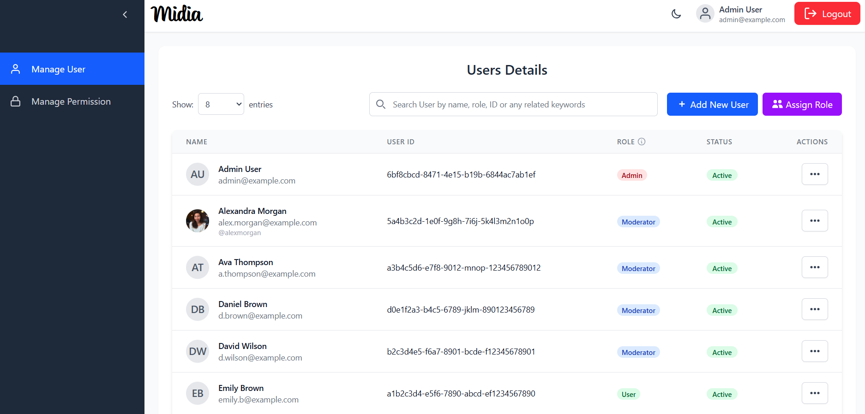

**Figure 3-9**: Screen Mockup of View User List

**Table 3-8: Screen Definition**

| **#** | **Field Name** | **Type** | **Mandatory** | **Max Length** | **Description** |
| --- | --- | --- | --- | --- | --- |
| 1 | Show Entries | Dropdown | Yes | N/A | A dropdown to select the number of user records displayed per page. |
| 2 | Search | Text Input | No | 100 | A search bar to filter the user list by keywords such as name, role, or ID. |
| 3 | Name | Text (with avatar) | Yes | N/A | Displays the user's avatar, full name, and email address. |
| 4 | User ID | Text | Yes | N/A | The unique identifier for the user. |
| 5 | Role | Tag | Yes | 20 | A colored tag indicating the user's assigned role (e.g., Admin, Moderator). |
| 6 | Status | Chip | Yes | 15 | A colored tag showing the user's account status (e.g., Active). |
| 7 | Actions | Button (Menu) | Yes | N/A | A menu button (three dots) that reveals a list of actions for the specific user, including Edit, Toggle status, View Details. |

##### 3.9.1.2 Use Case Description

| **Use Case ID** | | **AD-01** | **Use Case Name** | | **View user list** | |
| --- | --- | --- | --- | --- | --- | --- |
| **Author** | | **ThangLT** | **Version** | **1.0** | **Date** | **20/07/2025** |
| **Actor** | | Admin | | | | |
| **Description** | | This use case allows an administrator to view a list of all registered users in the system. The list can be searched and is displayed in pages. Each entry shows the user's name, ID, role, and status. | | | | |
| **Precondition** | | PRE-01: The user is signed in.  PRE-02: The user has administrative privileges to access the user list. | | | | |
| **Trigger** | | TRG-01: The administrator opens the “User Details” section of the administration dashboard. | | | | |
| **Post-Condition** | | POS-01: A table showing the list of users is displayed.  POS-02: If the number of users exceeds the page limit, pagination controls appear.  POS-03: The total number of users is displayed. | | | | |
| **Main flows** | | | | | | |
| ***Step*** | ***Actor*** | ***Action*** | | | | |
| *1* | Admin | Navigates to the "Users Details" management screen. | | | | |
| *2* | Midia | Verifies that the user has the necessary access rights. | | | | |
| *3* | Midia | Retrieves a list of users, limited to the number allowed per page. | | | | |
| *4* | Midia | Displays the list of users in a table format, showing each user’s name, ID, role, and status. | | | | |
| *5* | Midia | Displays the total number of users and shows pagination controls if applicable. | | | | |

**Alternative flows**

| **AT1** | At step 3, if the admin does not have the required permissions: | |
| --- | --- | --- |
| **Sub step** | **Actor** | **Action** |
| 3.1 | Midia | Denies access to the user list. |
| 3.2 | Client | Displays an error message “You do not have permission to view this page.” |

| **AT2** | At step 4, there are no registered users in the system. | |
| --- | --- | --- |
| **Sub step** | **Actor** | **Action** |
| 3.1 | Midia | shows an empty table. |
| 3.2 | Midia | Displays a message within the table area: "No users found." |

| **AT3** | The administrator uses the search bar to filter the list. | |
| --- | --- | --- |
| **Sub step** | **Actor** | **Action** |
| 1 | Admin | Types a keyword (e.g., a name, role, or ID) into the search input field. |
| 2 | Client | Filters the list of users based on the keyword. |
| 3 | Midia | Displays only the users that match the search criteria. |

***Business Rules***

| **#** | **Rule Description** |
| --- | --- |
| BR-31 | The search should ignore letter case and match partial text in user name, ID, or role. |
| BR-32 | Each user entry includes an “Actions” menu that provides additional options for user management, such as editing details or updating roles. |

#### 3.9.2 View user detail

##### 3.9.2.1 Screen Mock-up

### 

**Figure 3-9**: Screen Mockup of View User Detail

**Table 3-9: Screen Definition**

| **#** | **Field Name** | **Type** | **Mandatory** | **Max Length** | **Description** |
| --- | --- | --- | --- | --- | --- |
| 1 | Avatar | Image | Yes | N/A | The user's profile picture displayed at the top. |
| 2 | Full name | Text | Yes | 100 | The complete name of the user. |
| 3 | Email | Text | Yes | 100 | The user's primary email address. |
| 4 | Role | Chip | Yes | 20 | A tag indicating the user's assigned role (e.g., Moderator). |
| 5 | User ID | Text | Yes | N/A | The unique, non-editable system identifier for the user. |
| 6 | Username | Text | Yes | 50 | The user's unique username. |
| 7 | Email Verification Status | Icon + Text | Yes | N/A | Indicates whether the user's email has been verified. |
| 8 | Account Status | Icon + Text | Yes | N/A | Shows the current status of the user's account (e.g., Active, Locked). |
| 9 | Profile Information | Section | Yes | N/A | A container for the user's personal details like phone number, date of birth, and bio. |
| 10 | Statistic | Number | Yes | N/A | A section displaying key metrics: total followers, total following, and total posts. |
| 11 | Connected Timeline | Text | Yes | N/A | A list of social media accounts (e.g., Google, Facebook) linked to the user's profile. |
| 12 | Account Timeline | Text | Yes | N/A | Displays the timestamps for when the account was created and last updated. |
| 13 | Close button | Button | Yes | N/A | A button to dismiss or close the user profile view. |

##### 3.9.2.2 Use Case Description

| **Use Case ID** | | **AD-02** | **Use Case Name** | | **View user detail** | |
| --- | --- | --- | --- | --- | --- | --- |
| **Author** | | **ThangLT** | **Version** | **1.0** | **Date** | **20/07/2025** |
| **Actor** | | Auth User | | | | |
| **Description** | | This use case allows a signed-in user to view detailed information about another user. The details shown depend on the viewer’s permissions. For example, administrators may see more information than regular users. | | | | |
| **Precondition** | | PRE-01: The viewing user is signed in.  PRE-02: The user profile being viewed exists in the system. | | | | |
| **Trigger** | | TRG-01: The user clicks on a name, avatar, or row associated with a user in a user list or elsewhere in the application. | | | | |
| **Post-Condition** | | POS-01: A full user profile is displayed as a separate page. | | | | |
| **Main flows** | | | | | | |
| ***Step*** | ***Actor*** | ***Action*** | | | | |
| *1* | Admin | Clicks on another user's name, avatar, or profile link. | | | | |
| *2* | Midia | Checks if the user has permission to view detailed profiles. | | | | |
| *3* | Midia | Retrieves the full profile of the selected user. | | | | |
| *4* | Midia | Displays the profile, which may include sections such as:   * Basic Information (e.g., name, email) * Profile Information (e.g., role, status) * Activity Statistics * Linked Accounts * Account History or Timeline | | | | |

**Alternative flows**

| **AT1** | At step 2, the requested userId does not exist. | |
| --- | --- | --- |
| **Sub step** | **Actor** | **Action** |
| 2.1 | Midia | The System detects that the user does not exist. |
| 2.2 | Midia | The System shows an error message: “This user could not be found.” |

| **AT2** | At step 3, viewer not authenticated | |
| --- | --- | --- |
| **Sub step** | **Actor** | **Action** |
| 3.1 | Midia | Blocks the request to view the profile. |
| 3.2 | Midia | Redirects the user to the login screen or displays a message stating that authentication is required. |

***Business Rules***

| **#** | **Rule Description** |
| --- | --- |
| BR-31 | The level of detail shown in a user profile is based on the permissions of the person viewing it. |
| BR-32 | If the viewer is an administrator, all profile sections are visible. Regular users may see a limited view. |

#### 3.9.3 Add new user

##### 3.9.3.1 Screen Mock-up

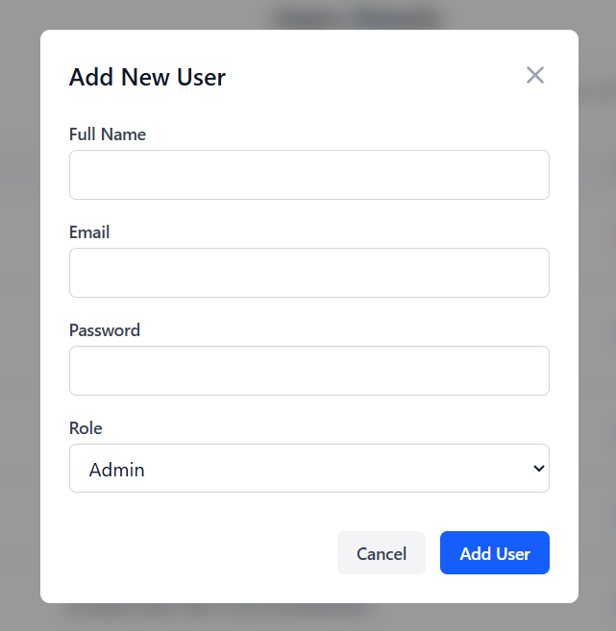

**Figure 3-9**: Screen Mockup of Add New User

**Table 3-9: Screen Definition**

| **#** | **Field Name** | **Type** | **Mandatory** | **Max Length** | **Description** |
| --- | --- | --- | --- | --- | --- |
| 1 | Password | Text Input | Yes | 100 | An input field for setting the user's password. The characters should be masked. |
| 2 | Full name | Text Input | Yes | 100 | The complete name of the user. |
| 3 | Email | Text Input | Yes | 100 | The user's primary email address. |
| 4 | Role | Dropdown | Yes | N/A | A dropdown menu to select and assign a role (e.g., Admin, Moderator, User) to the new user. |
| 5 | Cancel | Button | Yes | N/A | A button that discards any input and closes the "Add New User" modal. |
| 6 | Add User Button | Button | Yes | N/A | The primary action button that submits the form to create the user account. |

##### 3.9.3.2 Use Case Description

| **Use Case ID** | | **AD-03** | **Use Case Name** | | **Add a new user** | |
| --- | --- | --- | --- | --- | --- | --- |
| **Author** | | **ThangLT** | **Version** | **1.0** | **Date** | **20/07/2025** |
| **Actor** | | Admin | | | | |
| **Description** | | This use case allows an administrator to create a new user account by entering the user's name, email address, a temporary password, and assigning a role. This is done through the user management interface in the admin dashboard. | | | | |
| **Precondition** | | PRE-01: The administrator is signed in.  PRE-02: The administrator has permission to create new user accounts. | | | | |
| **Trigger** | | TRG-01: The administrator clicks the “Add New User” button in the user management section. | | | | |
| **Post-Condition** | | POS-01: A new user account is created with the provided details and role.  POS-02: The "Add New User" modal is closed.  POS-03: The user list is updated to show the newly added user. | | | | |
| **Main flows** | | | | | | |
| ***Step*** | ***Actor*** | ***Action*** | | | | |
| *1* | Admin | Clicks the "Add New User" button. | | | | |
| *2* | Midia | Displays the "Add New User" modal with input fields for Full Name, Email, Password, and a Role dropdown. | | | | |
| *3* | Admin | Fills in the required user details and selects a role from the dropdown. | | | | |
| *4* | Admin | Clicks the "Add User" button. | | | | |
| *5* | Midia | Checks if the administrator has permission to add users. | | | | |
| *6* | Midia | Validates the information, including checking whether the email address is already in use. | | | | |
| 7 | Midia | Creates the new user account using the provided details. | | | | |
| 8 | Midia | Confirms success, closes the form, and refreshes the user list to display the new entry. | | | | |
| 9 | Midia | Displays a success message: “User created successfully.” | | | | |

**Alternative flows**

| **AT1** | At step 7, the provided email address already exists in the system. | |
| --- | --- | --- |
| **Sub step** | **Actor** | **Action** |
| 7.1 | Midia | Detects that the email is not unique. |
| 7.2 | Midia | Displays an error message next to the email field: “Email already taken.” |
| 7.3 | Midia | Keeps the form open for correction. |

| **AT2** | At step 6, the administrator does not have permission to create users | |
| --- | --- | --- |
| **Sub step** | **Actor** | **Action** |
| 6.1 | Midia | Denies the request. |
| 6.2 | Midia | Displays an error message: "You do not have permission to perform this action." |

| **AT3** | At step 4, the administrator clicks the "Cancel" button. | |
| --- | --- | --- |
| **Sub step** | **Actor** | **Action** |
| 4.1 | Midia | Discards the entered information and closes the form. |

***Business Rules***

| **#** | **Rule Description** |
| --- | --- |
| BR-31 | Only users with permission to create accounts can access this functionality. |
| BR-32 | Email addresses for new users must be unique in the system. |

#### 

#### 3.9.4 Edit user role

##### 3.9.4.1 Screen Mock-up

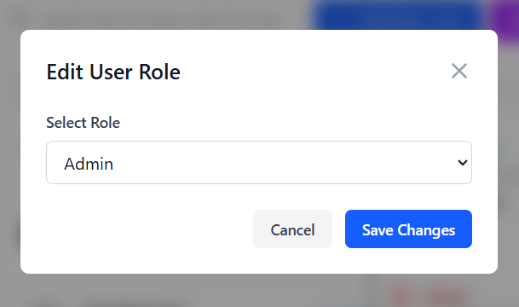

**Figure 3-9**: Screen Mockup of Add New User

**Table 3-9: Screen Definition**

| **#** | **Field Name** | **Type** | **Mandatory** | **Max Length** | **Description** |
| --- | --- | --- | --- | --- | --- |
| 1 | Select role | Dropdown | Yes | N/A | A dropdown menu to select a new role for the user. It should be populated with all available system roles (e.g., Admin, Moderator, User). |
| 2 | Cancel Button | Button | Yes | N/A | A button to close the modal and discard the role change. |
| 3 | Save Changes Button | Button | Yes | N/A | The primary button that confirms the selection and updates the user's role. |

##### 

##### 3.9.4.2 Use Case Description

| **Use Case ID** | | **AD-04** | **Use Case Name** | | **Add a new user** | |
| --- | --- | --- | --- | --- | --- | --- |
| **Author** | | **ThangLT** | **Version** | **1.0** | **Date** | **20/07/2025** |
| **Actor** | | Admin | | | | |
| **Description** | | This use case allows an administrator to change the role of an existing user. Changing a user's role directly affects their permissions and access rights within the system. | | | | |
| **Precondition** | | PRE-01: The administrator is signed in.  PRE-02: The administrator has permission to manage user roles.  PRE-03: The target user exists in the system. | | | | |
| **Trigger** | | TRG-01: The administrator opens the actions menu for a user and selects the “Edit Role” option. | | | | |
| **Post-Condition** | | POS-01: The selected user’s role is updated.  POS-02: The role editor window is closed.  POS-03: The user list is refreshed to show the updated role. | | | | |
| **Main flows** | | | | | | |
| ***Step*** | ***Actor*** | ***Action*** | | | | |
| *1* | Admin | Clicks the "Actions" menu for a user and selects "Edit Role". | | | | |
| *2* | Midia | Displays a form showing the user’s current role and a list of available roles. | | | | |
| *3* | Admin | Selects a new role from the "Select Role" dropdown menu. | | | | |
| *4* | Admin | Clicks the "Save Changes" button. | | | | |
| *5* | Midia | Checks that the administrator has permission to update user roles. | | | | |
| *6* | Midia | Updates the user’s role to the newly selected one. | | | | |
| 7 | Midia | Confirms success, closes the form, and refreshes the user list. | | | | |
| 8 | Midia | Displays a success message: “User role updated.” | | | | |

**Alternative flows**

| **AT1** | At step 6, the administrator lacks the required update_user permission. | |
| --- | --- | --- |
| **Sub step** | **Actor** | **Action** |
| 6.1 | Midia | The userRepository.existsByEmail() check returns true |
| 6.2 | Midia | Responds with a "FORBIDDEN" error. |
| 6.3 | Client | Displays an error message: "You do not have permission to perform this action." |

| **AT2** | At step 7, the target user's ID is invalid and the user cannot be found. | |
| --- | --- | --- |
| **Sub step** | **Actor** | **Action** |
| 7.1 | Midia | The userRepository.findById() call returns empty, and a UserNotExistsException is thrown. |
| 7.2 | Midia | Responds with a BAD_REQUEST error and the message "User not exists." |
| 7.3 | Client | Displays an error message inside the modal. |

| **AT3** | At step 4, the administrator clicks the "Cancel" button. | |
| --- | --- | --- |
| **Sub step** | **Actor** | **Action** |
| 4.1 | Client | Discards the selection and closes the "Edit User Role" modal. The use case ends. |

***Business Rules***

| **#** | **Rule Description** |
| --- | --- |
| BR-31 | Only users with the update_user permission can change another user's role. |
| BR-32 | A user’s role determines their access level and available features within the system. |
| BR-33 | An administrator cannot edit their own role through this interface to prevent accidental self-demotion. |

#### 3.9.5 Assign role to users

##### 3.9.5.1 Screen Mock-up

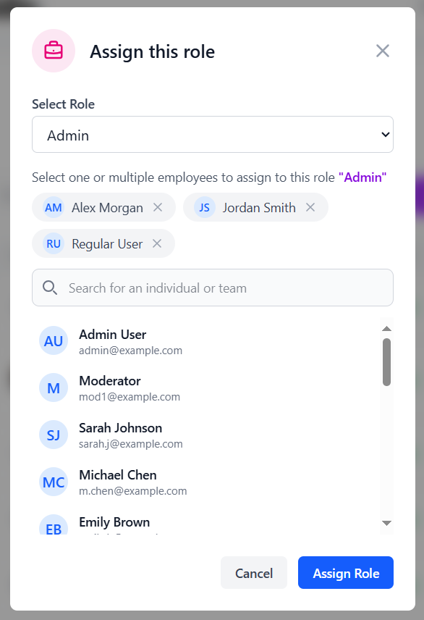

**Figure 3-9**: Screen Mockup of Assign role

**Table 3-9: Screen Definition**

| **#** | **Field Name** | **Type** | **Mandatory** | **Max Length** | **Description** |
| --- | --- | --- | --- | --- | --- |
| 1 | Select role | Dropdown | Yes | N/A | A dropdown menu to select a new role for the user. It should be populated with all available system roles (e.g., Admin, Moderator, User). |
| 2 | Selected Users | Tag | Yes | N/A | A display area showing all users currently selected for the role assignment. Each user appears as a removable tag. |
| 3 | User Search | Text Input | No | 100 | A search field to find and filter individuals or teams from the list of available users. |
| 4 | Available Users List | List | Yes | N/A | A scrollable list showing all users who can be selected. Clicking a user in this list adds them to the "Selected Users" area above. |
| 5 | Cancel button | Button | Yes | N/A | A button to close the modal without saving any changes. |
| 6 | Assign Role Button | Button | Yes | N/A | The primary action button to confirm and apply the selected role to all chosen users. |

##### 

##### 3.9.5.2 Use Case Description

| **Use Case ID** | | **AD-05** | **Use Case Name** | | **Assign role to users** | |
| --- | --- | --- | --- | --- | --- | --- |
| **Author** | | **ThangLT** | **Version** | **1.0** | **Date** | **20/07/2025** |
| **Actor** | | Admin | | | | |
| **Description** | | This use case allows an administrator to assign the same role to multiple users at once. This bulk operation helps streamline role management through a dedicated interface. | | | | |
| **Precondition** | | PRE-01: The administrator is signed in.  PRE-02: The administrator has permission to update user roles. | | | | |
| **Trigger** | | TRG-01: The administrator clicks the “Assign Role” button in the user management interface. | | | | |
| **Post-Condition** | | POS-01: The selected role is applied to all chosen users.  POS-02: The role assignment window is closed.  POS-03: The main user list is refreshed to show the updated roles. | | | | |
| **Main flows** | | | | | | |
| ***Step*** | ***Actor*** | ***Action*** | | | | |
| *1* | Admin | Click the “Assign Role” button from the user management screen. | | | | |
| *2* | Midia | Displays a form allowing the admin to choose a role and select multiple users. | | | | |
| *3* | Admin | Selects a role from a dropdown list. | | | | |
| *4* | Midia | Searches for and selects one or more users to assign the role to. | | | | |
| *5* | Admin | Click the "Assign Role" button to confirm the action. | | | | |
| *6* | Midia | Checks that the admin has permission to update user roles. | | | | |
| 7 | Midia | Applies the selected role to each chosen user. | | | | |
| 8 | Midia | Confirms the role assignment, closes the form, and refreshes the user list. | | | | |
| 9 | Client | Shows a message: “Roles assigned successfully.” | | | | |

**Alternative flows**

| **AT1** | At step 7, administrator lacks permission | |
| --- | --- | --- |
| **Sub step** | **Actor** | **Action** |
| 7.1 | Midia | The System blocks the request. |
| 7.2 | Midia | Shows an error message: “You do not have permission to perform this action.” |

| **AT2** | At step 8, one of the selected user IDs is invalid or does not exist. | |
| --- | --- | --- |
| **Sub step** | **Actor** | **Action** |
| 8.1 | Midia | Skips the invalid users and processes the valid ones. |
| 8.2 | Midia | Displays a message such as: “Roles assigned. Some users could not be found.” |

| **AT3** | At step 5, the administrator clicks the "Cancel" button. | |
| --- | --- | --- |
| **Sub step** | **Actor** | **Action** |
| 4.1 | Client | The Admin clicks “Cancel.” |
| 4.2 | Midia | Discards the selections and closes the form. |

***Business Rules***

| **#** | **Rule Description** |
| --- | --- |
| BR-31 | A single role can be assigned to multiple users in one action. |
| BR-32 | Only users with the appropriate permission can assign roles. |
| BR-33 | If some selected users are invalid, the system completes the valid assignments and notifies the admin of partial success. |
| BR-34 | The user search function must support quick filtering to efficiently locate users. |

#### 3.9.6 Toggle status

##### 3.9.6.1 Screen Mock-up

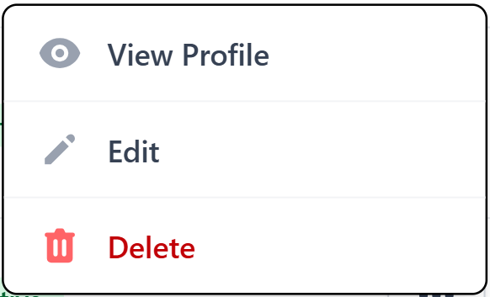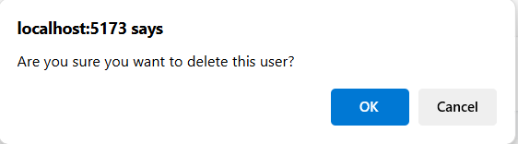

**Figure 3-9**: Screen Mockup of toggle status

**Table 3-9: Screen Definition**

| **#** | **Field Name** | **Type** | **Mandatory** | **Max Length** | **Description** |
| --- | --- | --- | --- | --- | --- |
| 1 | Toggle Status Button | Menu | Yes | N/A | An option in the user "Actions" menu. The text would dynamically change to "Deactivate" for an active user and "Activate" for an inactive one. |
| 2 | Confirmation Dialog | Modal | Yes | N/A | A system alert that would appear after clicking the "Toggle Status" button, asking the admin to confirm the action. |
| 3 | Confirmation Message | Text | Yes | 150 | The text within the dialog, such as "Are you sure you want to deactivate this user's account?". |
| 4 | Ok Button | Button | Yes | N/A | The button that confirms the status change. |
| 5 | Cancel button | Button | Yes | N/A | The button that aborts the action and closes the confirmation dialog. |

##### 3.9.6.2 Use Case Description

| **Use Case ID** | | **AD-06** | **Use Case Name** | | **Toggle status** | |
| --- | --- | --- | --- | --- | --- | --- |
| **Author** | | **ThangLT** | **Version** | **1.0** | **Date** | **20/07/2025** |
| **Actor** | | Admin | | | | |
| **Description** | | This use case allows an administrator to change the activation status of a user account. When an account is deactivated, the user will no longer be able to sign in. Reactivating the account restores access. | | | | |
| **Precondition** | | PRE-01: The administrator is signed in.  PRE-02: The administrator has permission to manage user accounts.  PRE-03: The user whose account is being managed exists in the system. | | | | |
| **Trigger** | | TRG-01: The administrator selects “Deactivate” or “Activate” from the actions menu for a specific user. | | | | |
| **Post-Condition** | | POS-01: The user’s account status is updated (active or inactive).  POS-02: The system interface is refreshed, showing the new status.  POS-03: A confirmation message is shown to the administrator. | | | | |
| **Main flows** | | | | | | |
| ***Step*** | ***Actor*** | ***Action*** | | | | |
| *1* | Admin | Selects the “Activate” or “Deactivate” option for a user from the actions menu. | | | | |
| *2* | Midia | Displays a confirmation prompt asking the admin to confirm the action. | | | | |
| *3* | Midia | Clicks the "OK" button to confirm. | | | | |
| *4* | Midia | Checks whether the administrator has permission to update user accounts. | | | | |
| *5* | Midia | Updates the selected user's status (active or inactive). | | | | |
| *6* | Midia | Closes the confirmation dialog and refreshes the user list. | | | | |
| 7 | Midia | Displays a message indicating that the account has been updated (e.g., “User has been deactivated”). | | | | |

**Alternative flows**

| **AT1** | At step 5, the administrator lacks the required update_user permission. | |
| --- | --- | --- |
| **Sub step** | **Actor** | **Action** |
| 5.1 | Midia | The System blocks the action. |
| 5.2 | Midia | Displays an error message: "You do not have permission to perform this action." |

| **AT2** | At step 3, the administrator clicks the "Cancel" button in the confirmation dialog. | |
| --- | --- | --- |
| **Sub step** | **Actor** | **Action** |
| 3.1 | Midia | Closes the confirmation dialog. The use case ends with no changes made. |

| **AT3** | At step 6, the administrator attempts to deactivate their own account. | |
| --- | --- | --- |
| **Sub step** | **Actor** | **Action** |
| 6.1 | Midia | Detects the action. |
| 6.2 | Midia | Blocks the request and displays an error message: “You cannot deactivate your own account.” |

***Business Rules***

| **#** | **Rule Description** |
| --- | --- |
| BR-31 | An administrator cannot deactivate their own account. |
| BR-32 | Only users with the appropriate permission can change account status. |
| BR-33 | Deactivation is reversible — a deactivated account can be reactivated at any time by an authorized administrator. |

#### 3.9.7 View roles & permissions

##### 3.9.7.1 Screen Mock-up

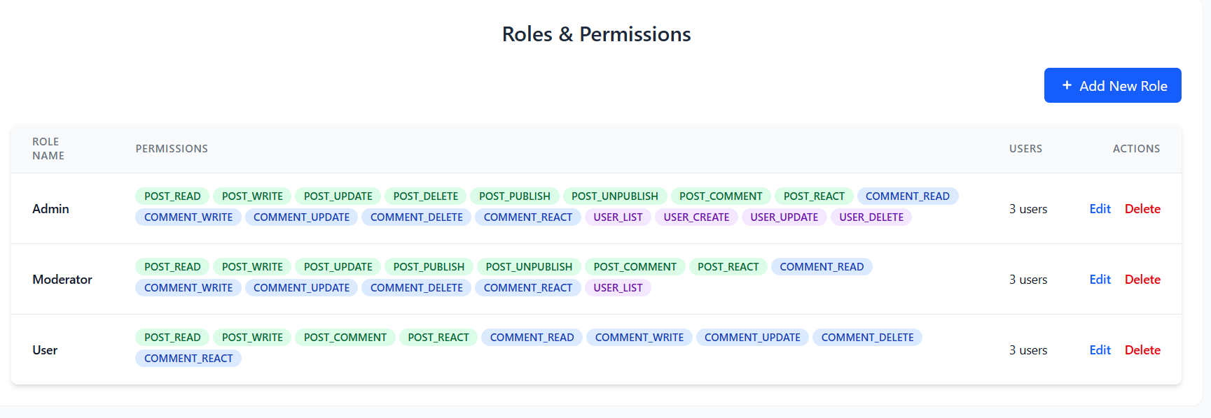

**Figure 3-9**: Screen Mockup of view roles and permissions

**Table 3-9: Screen Definition**

| **#** | **Field Name** | **Type** | **Mandatory** | **Max Length** | **Description** |
| --- | --- | --- | --- | --- | --- |
| 1 | Add New Role Button | Button | Yes | N/A | A primary button that opens a form or modal to create a new role and assign permissions to it. |
| 2 | Role Name | Text | Yes | 50 | The unique name of the role (e.g., Admin, Moderator, User). This is the primary identifier for the role. |
| 3 | Permissions | Chip List | No | N/A | A collection of colored tags, where each tag represents a specific permission (e.g., POST_READ, USER_DELETE) granted to that role. |
| 4 | Users | Text | Yes | N/A | A text display showing the total count of users currently assigned to the corresponding role. |
| 5 | Actions | Buttons | Yes | N/A | A set of actions ("Edit", "Delete") that can be performed on the role to modify its name/permissions or remove it from the system. |

##### 

## 4. Non-Functional Requirements

### 4.1 External Interfaces

* The system will interact with users with a standard web browser such as Microsoft Edge, Chrome, Opera,…
* **Database Storage**: Store accounts, posts,...

### 4.2 Quality Attributes

#### 4.2.1 Usability

* The UI must be simple and intuitive that normal users can understand how to use quickly and easily
* The UI must follow the usability standards such as
  + Naming elements clearly
  + Input validation notification
  + Navigation consistency
* The UI have cleaned and responsive layout

#### 4.2.2 Reliability

* Availability: The system should be available 99.98% hours of use, equivalent to downtime for 20 minutes per month.
* Mean Time Between Failures (MTBF): Should be larger than 3000 hours
* Mean Time To Repair (MTTR): Should be less than 30 minutes
* Backup & Recovery: Backup by block for each 6 hours and save it for a month
* Maximum Bugs: Must less than 10 bugs/KLOC

#### 4.2.3 Performance

* **Response Time**: Average response time is not larger than 1 second
* **Throughput**: The system can support concurrent active users accessing in one time (minimum 100 reqs/sec)
* **Latency for Media Delivery**: Preview image should be displayed no more than one second

## 5. Requirement Appendix

### 5.1 Business Rules

| **ID** | **Rule Definition** |
| --- | --- |
| BR-01 | Maximum of 20 notifications are fetched per request; subsequent pages use cursor-based pagination. |
| BR-02 | Notifications are considered unread when readAt is null. |
| BR-03 | Returned list must be strictly ordered by createdAt descending before grouping into sections. |
| BR-04 | Notifications older than 30 days are auto-archived and excluded from the “recent” endpoint. |
| BR-05 | The unread badge should never exceed “99+” characters; counts above 99 display as “99+”. |
| BR-06 | CTA mapping table determines which API endpoint is invoked per eventType (e.g., FOLLOW_REQUEST, MENTION, LIKE). |
| BR-07 | A notification is auto-marked read after any successful CTA action or row navigation. |
| BR-08 | Follow/unfollow actions are rate-limited to 30 per hour per user to mitigate spam. |
| BR-09 | If the action has already been performed (e.g., user is already following), the service returns 409 Conflict; client shows inline warning without altering unread count. |
| BR-10 | Media Required: A post must contain exactly one media file (image or video). |
| BR-11 | Supported File Formats: The system shall only accept media files with the following extensions: .jpg, .jpeg, .png for images, and .mp4 for videos. |
| BR-12 | Maximum File Size: The size of the uploaded media file must not exceed 10MB for images and 100MB for videos. |
| BR-13- | Caption Length: The text caption is optional, but if provided, it must not exceed 2,200 characters. |
| BR-14 | Phone number must have 11 digits and is existed |
| BR-15 | Username must be unique |
| BR-16 | List of suggestions must be limited in 5 accounts |
| BR-17 | Phone number must have 11 digits and is existed |
| BR-18 | Username must be unique |
| BR-19 | Image file must be maximum 5MB |
| BR-20 | Image’s format should be JPG, PNG or WEBP |
| BR-21 | Username must be unique and password must be hashed securely. |
| BR-22 | Only active users (not locked or banned) can log in. |
| BR-23 | Google login is optional and only available if the email is verified. |
| BR-24 | Username and email must be unique |
| BR-25 | Password must be at least 8 characters |
| BR-26 | User must enter a valid and registered email address to initiate password reset |
| BR-27 | Password reset token must be unique, secure |
| BR-28 | New password must meet minimum security requirements (e.g., minimum 8 characters, include letters and numbers) |
| BR-29 | Password and Confirm Password must match before submission |
| BR-30 | Only verified accounts are allowed to reset their password via email |
| BR-31 | Users can only like or comment on a post if they are logged in |
| BR-32 | Each comment is limited to 200 characters |
| BR-33 | Username display is limited to 20 characters |
| BR-34 | "More Options" dropdown includes: Report Post, Share Post, Copy Link |
| BR-35 | Suggested users are based on similar interests, friends of friends, or system recommendation engine |

### 5.2 Common Requirements

### 5.3 Application Messages List

| **#** | **Message code** | **Message Type** | **Context** | **Content** |
| --- | --- | --- | --- | --- |
| 1 | MSG01 | In line | There is not any search result | *No search results.* |
| 2 | MSG02 | In red, under the text box | Input-required fields are empty | *The * field is required.* |
| 3 | MSG03 | Toast message | Updating asset(s) information successfully | *Update asset(s) successfully.* |
| 4 | MSG04 | Toast message | Adding new asset successfully | *Add asset successfully.* |
| 5 | MSG05 | Toast message | Confirming email of asset hand-over is sent successfully | *A confirmation email has been sent to {email_address}.* |
| 6 | MSG06 | Toast message | Resetting asset information successfully | *Return asset(s) successfully.* |
| 7 | MSG07 | Toast message | Deleting asset information successfully | *Delete asset(s) successfully.* |
| 8 | MSG08 | In red, under the text box | Input value length > max length | *Exceed max length of {max_length}.* |
| 9 | MSG09 | In line | Username or password is not correct when clicking sign-in | *Incorrect username or password. Please check again.* |

### 